Acoustic Rapid COTS Insertion (ARCI)

Software Requirements Specification (SRS)

Program Control Directives (PCD) Tracker



**“Keep It Simple”**

Prepared For:

Joey Eubank | Program Management Senior Manager | 703-367-3214

Prepared By:

Lockheed Martin Corporation

Rotary and Missions Systems (RMS)

9500 Godwin Drive

Manassas, VA 20110

Eugene J. Belford

CONTRACT NUMBER:

Document Name:

Point of Contact

Cyrus Sabzevari | Software Engineering Manager | 703-367-6366

[cyrus.sabzevari@lmco.com](mailto:cyrus.sabzevari@lmco.com)

Change History

|  |  |  |  |
| --- | --- | --- | --- |
| **Date** | **Version** | **Description** | **Author** |

|  |  |  |  |
| --- | --- | --- | --- |
| 5/22/2017 | 0.1 | Review copy provided to Mr. Eubanks | Gene Belford |
| 11/9/2017 | 0.2 | Working Copy | Gene Belford |
| 11/16/2017 | 0.3 | Pre-Drop Cleanup | Gene Belford |
|  | 1.0 | Initial Draft |  |
|  |  |  |  |
|  |  |  |  |
|  |  |  |  |

Table of Contents

1. Purpose 1

1.1 Overview 1

1.2 Objectives 1

1.3 Current PCD Purpose 1

1.4 Updated Tool Requirements 2

2. Tracker Functions 3

2.1 Status Summary 3

2.1.1 Human Machine Interfaces 4

2.1.2 Requirements 4

2.1.3 Business Rules 5

2.1.4 Functions 5

2.1.5 Data Objects 5

2.1.6 Views 5

2.1.7 Complexity 5

2.1.8 Implementation 6

2.2 Remarks Entry 8

2.2.1 Human Machine Interface 8

2.2.2 Requirements 8

2.2.3 Business Rules 8

2.2.4 Functions 8

2.2.5 Data Objects 9

2.2.6 Views 9

2.2.7 Complexity 9

2.2.8 Implementation 9

2.3 Feedback Entry 10

2.3.1 Human Machine Interfaces 10

2.3.2 Requirements 10

2.3.3 Business Rules 10

2.3.4 Views 10

2.3.5 Functions 10

2.3.6 Data Objects 10

2.3.7 Enumerations 11

2.3.8 Complexity 11

2.3.9 Implementation 11

2.4 PCD Tracker Entry 12

2.4.1 Human Machine Interface 13

2.4.1.1 PCD Tracker Entry (Blank) 13

2.4.2 Implementation 16

2.4.2.1 PCD Tracker Entry (Populated) 17

2.4.2.2 Requirements 17

2.4.2.3 Business Rules 17

2.4.3 Functions 17

2.4.4 Data Objects 18

2.4.5 Enumerations 18

2.4.6 Complexity 18

2.5 PCD Tracker Maintenance 19

2.5.1 Human Machine Interfaces 20

2.5.2 Requirements 21

2.5.3 Business Rules 21

2.5.4 Functions 21

2.5.5 Data Objects 21

2.5.6 Enumerations 21

2.5.7 Complexity 21

2.6 PCD Material List Entry 22

2.6.1 Human Machine Interfaces 23

2.6.2 Requirements 24

2.6.3 Business Rules 24

2.6.4 Functions 24

2.6.5 Data Objects 24

2.6.6 Enumerations 24

2.6.7 Complexity 24

2.7 PCD Draft 25

2.7.1 Human Machine Interfaces 25

2.7.1.1 PCD Draft (Collapsed) 25

2.7.1.2 PCD Draft (Expanded I) 27

2.7.1.3 PCD Draft (Expanded II) 29

2.7.2 Functions 30

2.7.3 Data Objects 30

2.7.4 Enumerations 30

2.7.5 Complexity 30

2.8 PCD Entry 31

2.8.1 Human Machine Interfaces 31

2.8.2 Requirements 32

2.8.3 Business Rules 32

2.8.4 Functions 32

2.8.5 Data Objects 32

2.8.6 Enumerations 32

2.8.7 Complexity 32

2.9 PCD Generic View 33

2.9.1 Human Machine Interfaces 33

2.9.1.1 (I) 33

2.9.1.2 (II) 34

2.9.1.3 Buttons 35

2.9.2 Views 35

2.9.3 Functions 35

2.9.4 Data Objects 35

2.9.5 Enumerations 35

2.9.6 Complexity 35

2.10 PCD Status Search / Report Parameters 36

2.10.1 Human Machine Interfaces 37

2.10.2 Requirements 37

2.10.3 Business Rules 37

2.10.4 Functions 37

2.10.5 Data Objects 38

2.10.6 Enumerations 38

2.10.7 Complexity 38

2.11 [CSC Name] CSC 39

2.11.1 [Function Name] 39

2.11.1.1 Test Method 39

2.11.1.2 Algorithms (if applicable) 39

2.11.1.3 SW Reuse (if applicable) 39

2.11.1.4 Requirements Traceability 40

3. PCD Working Modes 40

4. Database Views 42

4.1 Database View Menu 42

4.2 Enumeration List 43

4.2.1 Human Machine Interfaces 43

4.2.2 Requirements 43

4.2.3 Business Rules 43

4.2.4 Views 43

4.2.5 Functions 43

4.2.6 Data Objects 43

4.2.7 Enumerations 43

4.2.8 Complexity 44

4.2.9 Implementation 44

4.3 Feedback List 45

4.3.1 Human Machine Interfaces 45

4.3.2 Requirements 45

4.3.3 Business Rules 45

4.3.4 Views 45

4.3.5 Functions 45

4.3.6 Data Objects 45

4.3.7 Enumerations 45

4.3.8 Complexity 46

4.3.9 Implementation 46

4.4 Remarks List 47

4.4.1 Human Machine Interfaces 47

4.4.2 Requirements 47

4.4.3 Business Rules 47

4.4.4 Views 47

4.4.5 Functions 47

4.4.6 Data Objects 47

4.4.7 Enumerations 47

4.4.8 Complexity 48

4.4.9 Implementation 48

4.5 Tracker List 49

4.5.1 Human Machine Interfaces 49

4.5.2 Requirements 49

4.5.3 Business Rules 49

4.5.4 Views 49

4.5.5 Functions 49

4.5.6 Data Objects 49

4.5.7 Enumerations 49

4.5.8 Complexity 50

4.5.9 Implementation 50

4.6 PCD List 51

4.6.1 Human Machine Interfaces 51

4.6.2 Requirements 51

4.6.3 Business Rules 51

4.6.4 Views 51

4.6.5 Functions 51

4.6.6 Data Objects 51

4.6.7 Enumerations 51

4.6.8 Complexity 52

4.6.9 Implementation 52

5. Common Function 53

5.1 Enumeration Helpers 53

5.1.1 Human Machine Interfaces 53

5.1.1.1 Drop Down List Box 54

5.1.1.2 Modal 55

5.1.2 Views 55

5.1.3 Functions 55

5.1.4 Data Objects 55

5.1.5 Enumerations 55

5.1.6 Complexity 56

5.2 Enumeration Types 56

5.2.1 Human Machine Interfaces 56

5.2.2 Requirements 56

5.2.3 Business Rules 57

5.2.4 Views 57

5.2.5 Functions 57

5.2.6 Data Objects 57

5.2.7 Enumerations 57

5.2.8 Complexity 57

5.2.9 Implementation 58

5.3 Enumeration Values 58

5.3.1 Human Machine Interfaces 59

5.3.2 Requirements 59

5.3.3 Business Rules 59

5.3.4 Views 59

5.3.5 Functions 59

5.3.6 Data Objects 59

5.3.7 Enumerations 59

5.3.8 Complexity 60

5.4 Enumeration Value Associations 60

5.4.1 Human Machine Interfaces 60

5.4.2 Requirements 60

5.4.3 Business Rules 60

5.4.4 Views 60

5.4.5 Functions 60

5.4.6 Data Objects 60

5.4.7 Enumerations 60

5.4.8 Complexity 60

5.5 Printable Version 61

5.5.1 Human Machine Interfaces 61

5.5.2 Requirements 61

5.5.3 Business Rules 61

5.5.4 Views 62

5.5.5 Functions 62

5.5.6 Data Objects 62

5.5.7 Enumerations 62

5.5.8 Complexity 62

5.6 Classification 63

5.6.1 Human Machine Interfaces 63

5.6.2 Requirements 63

5.6.3 Business Rules 63

5.6.4 Views 63

5.6.5 Functions 63

5.6.6 Data Objects 64

5.6.7 Enumerations 64

5.6.8 Complexity 64

5.7 Contracts / Purchase Order(s) 65

5.7.1 Human Machine Interfaces 65

5.7.2 Requirements 65

5.7.3 Business Rules 65

5.7.4 Views 65

5.7.5 Functions 65

5.7.6 Data Objects 65

5.7.7 Enumerations 65

5.7.8 Complexity 66

5.8 Assign Approver(s) 67

5.8.1 Human Machine Interfaces 67

5.8.2 Requirements 67

5.8.3 Business Rules 67

5.8.4 Views 67

5.8.5 Functions 67

5.8.6 Data Objects 67

5.8.7 Enumerations 67

5.8.8 Complexity 67

5.9 Directory Helper 69

5.9.1 Human Machine Interfaces 69

5.9.2 Requirements 69

5.9.3 Business Rules 69

5.9.4 Views 69

5.9.5 Functions 69

5.9.6 Data Objects 69

5.9.7 Enumerations 70

5.9.8 Complexity 70

5.10 Assign Programs 71

5.10.1 Human Machine Interfaces 71

5.10.2 Requirements 71

5.10.3 Business Rules 71

5.10.4 Views 71

5.10.5 Functions 71

5.10.6 Data Objects 71

5.10.7 Enumerations 71

5.10.8 Complexity 71

5.11 Attachments 73

5.11.1 Human Machine Interfaces 73

5.11.1.1 Add Attachment 73

5.11.1.2 File Browser 73

5.11.2 Views 74

5.11.3 Functions 74

5.11.4 Data Objects 74

5.11.5 Enumerations 74

5.11.6 Complexity 74

5.12 View Attachments 75

5.12.1 Human Machine Interfaces 75

5.12.2 Requirements 76

5.12.3 Business Rules 76

5.12.4 Views 76

5.12.5 Functions 76

5.12.6 Data Objects 76

5.12.7 Enumerations 76

5.12.8 Complexity 76

5.13 PCD Notification 76

5.13.1 Human Machine Interfaces 77

5.13.2 Requirements 77

5.13.3 Business Rules 77

5.13.4 Views 77

5.13.5 Functions 77

5.13.6 Data Objects 77

5.13.7 Enumerations 78

5.13.8 Complexity 78

5.14 About 79

5.14.1 Human Machine Interfaces 79

5.14.2 Requirements 79

5.14.3 Business Rules 79

5.14.4 Views 79

5.14.5 Functions 79

5.14.6 Data Objects 79

5.14.7 Enumerations 79

5.14.8 Complexity 80

5.15 PCD Users Guide 81

5.15.1 Human Machine Interfaces 81

5.15.2 Requirements 81

5.15.3 Business Rules 81

5.15.4 Views 81

5.15.5 Functions 81

5.15.6 Data Objects 82

5.15.7 Enumerations 82

5.15.8 Complexity 82

6. Application Functions 83

6.1 Contracts/Program List 83

6.1.1 Human Machine Interfaces 83

6.1.2 Requirements 84

6.1.3 Business Rules 84

6.1.4 Views 84

6.1.5 Functions 84

6.1.6 Data Objects 84

6.1.7 Enumerations 84

6.1.8 Complexity 84

6.2 Administration 84

6.2.1 Human Machine Interfaces 84

6.2.2 Requirements 84

6.2.3 Business Rules 85

6.2.4 Views 85

6.2.5 Functions 85

6.2.6 Data Objects 85

6.2.7 Enumerations 85

6.2.8 Complexity 85

6.3 PCD Summary 85

6.3.1 Human Machine Interfaces 86

6.3.2 Requirements 86

6.3.3 Business Rules 86

6.3.4 Views 86

6.3.5 Functions 86

6.3.6 Data Objects 86

6.3.7 Enumerations 86

6.3.8 Complexity 86

6.4 PCD Report 87

6.4.1 Human Machine Interfaces 87

6.4.2 Requirements 87

6.4.3 Business Rules 87

6.4.4 Views 87

6.4.5 Functions 87

6.4.6 Data Objects 88

6.4.7 Enumerations 88

6.4.8 Complexity 88

6.5 PCD Statistics 88

6.5.1 Human Machine Interfaces 88

6.5.2 Requirements 89

6.5.3 Business Rules 89

6.5.4 Views 90

6.5.5 Functions 90

6.5.6 Data Objects 90

6.5.7 Enumerations 90

6.5.8 Complexity 90

6.6 Contract Entry 90

6.6.1 Human Machine Interfaces 90

6.6.2 Requirements 90

6.6.3 Business Rules 90

6.6.4 Views 90

6.6.5 Functions 90

6.6.6 Data Objects 91

6.6.7 Enumerations 91

6.6.8 Complexity 91

6.7 Program Entry 91

6.7.1 Human Machine Interfaces 91

6.7.2 Requirements 91

6.7.3 Business Rules 91

6.7.4 Views 91

6.7.5 Functions 91

6.7.6 Data Objects 91

6.7.7 Enumerations 91

6.7.8 Complexity 92

6.8 User Entry 92

6.8.1 Human Machine Interfaces 92

6.8.2 Requirements 92

6.8.3 Business Rules 92

6.8.4 Views 92

6.8.5 Functions 92

6.8.6 Data Objects 92

6.8.7 Enumerations 92

6.8.8 Complexity 92

6.8.9 Implementation 93

7. Use Cases 93

7.1.1 [Use Case Name] 93

7.1.1.1 [Sequence | Activity] Diagram Name (optional) 93

7.1.1.2 Basic Flow 93

7.1.1.3 Alternate Flows 93

7.1.1.4 Exceptional Flows 93

8. Data Model 94

8.1 Tables 95

8.1.1 Trackers 95

8.1.2 PCD (Program Control Directives) 97

8.1.3 PCD Sequence 99

8.1.4 Hardware (Material) Lists 100

8.1.5 Hardware (Material) List Items 101

8.1.6 Remarks 102

8.1.7 Tasks 102

8.1.8 User Tasks 103

8.1.9 Contracts 103

8.1.10 Search Parameters 104

8.1.11 Attachments 104

8.1.12 Enumeration Types 105

8.1.13 Enumeration Values 106

8.1.14 Enumeration Value Associations 107

8.1.15 Boilerplate Suffix 108

8.1.16 Blank Table 109

8.2 Views 110

8.2.1 vw_end_of_life 110

8.2.2 vw_hw_list_all 110

8.2.3 vw_hw_list_items_all 110

8.2.4 vw_pcd_delivery_wakeup 110

8.2.5 vw_pcd_funded_no_pcd 110

8.2.6 vw_pcd_fy_not_funded 110

8.2.7 vw_pcd_wakeup 110

8.2.8 vw_remarks 110

8.2.9 vw_task_all 110

8.2.10 vw_tracker_active 110

8.2.11 vw_tracker_all 110

8.2.12 vw_tracker_pcd 110

8.2.13 vw_user_feedback_all 110

8.2.14 Blank View 111

8.3 Triggers 111

8.3.1 enum_types_insert_before 111

8.3.2 enum_values_insert_before 111

8.3.3 pcd_insert_before 111

8.3.4 remarks_insert_before 111

8.3.5 trackers_insert_before 111

8.3.6 111

8.4 Functions 112

8.4.1 f_create_pcd_id 112

8.4.2 f_remarks_string 112

8.4.3 uuid_v4 112

8.4.4 112

8.5 Procedures 112

8.5.1 112

8.6 Schema Post Deployment Scripts 112

8.6.1 112

9. [CSCI Name] CSCI 112

9.1 [CSC Name] CSC 112

9.1.1 [Function Name] 112

9.1.1.1 Test Method 113

9.1.1.2 Algorithms (if applicable) 113

9.1.1.3 SW Reuse (if applicable) 113

9.1.1.4 Requirements Traceability 113

9.2 Data Model 113

9.3 Interfaces 113

9.3.1 Graphical Interfaces (if applicable) 113

9.3.2 Message Interfaces (if applicable) 113

9.3.2.1 Provided Interfaces 113

9.3.2.2 Required Interfaces 113

10. Appendixes 113

10.1 Acronyms 113

10.2 Enumeration Types 114

10.3 Enumeration Values 115

Tables

Table 3‑1: PCD Working Modes 41

Table 7‑1: Trackers 95

Table 7‑2: Program Control Directives (PCD) 97

Table 7‑3: Hardware Lists 99

Table 7‑3: Hardware Lists 100

Table 7‑4: Hardware List Items 101

Table 7‑5: Remarks 102

Table 7‑6: Tasks 102

Table 7‑7: User Tasks 103

Table 7‑8: Contracts 103

Table 7‑9: Search Parameters 104

Table 7‑10: Attachments 104

Table 7‑11: Enumeration Types 105

Table 7‑12: Enumeration Values 106

Table 7‑13: Enumeration Value Associations 107

Table 7‑14: Boilerplate 108

Table 7‑15: Blank 109

Table 7‑15: Blank 111

Figures

Figure 2‑1: Status Summary 4

Figure 2‑2: Summary Status 6

Figure 2‑3: Advanced Filters Selection for Summary Status 6

Figure 2‑4: Right Functions for Summary Status 7

Figure 2‑5: Remarks Magnification 7

Figure 2‑6: Remarks Entry 8

Figure 2‑7: Remark Input 9

Figure 2‑8: Feedback Entry 10

Figure 2‑9: PCD Tracker Entry (Blank) 13

Figure 2‑10: Tracker Entry 16

Figure 2‑11: PCD Tracker Entry (Populated) 17

Figure 2‑12: PCD Tracker Maintenance 20

Figure 2‑13: PCD Material Entry List 23

Figure 2‑14: PCD Draft (Collapsed) 25

Figure 2‑15: PCD Draft (Expanded I) 27

Figure 2‑16: PCD Draft (Expanded II) 29

Figure 2‑17: PCD Entry 31

Figure 2‑18: PCD Generic View (I) 33

Figure 2‑19: PCD Generic View (II) 34

Figure 2‑20: PCD Status Search / Report Parameters 37

Figure 4‑1: Database Views Menu 42

Figure 4‑2: Enumeration Type and Value Maintenance 43

Figure 4‑3: Feedback List – Database Views 45

Figure 4‑4: Remark Maintenance 47

Figure 4‑5: Tracker Maintenance 49

Figure 4‑6: Tracker Maintenance 51

Figure 5‑1: Drop Down List Box 54

Figure 5‑2: Enumeration Modal View 55

Figure 5‑3: Enumeration Types 56

Figure 5‑4: Enumeration Type and Value Maintenance 58

Figure 5‑5: Enumeration Values 59

Figure 5‑6: Printable View 61

Figure 5‑7: PCD Classifications 63

Figure 5‑8: PCD References 65

Figure 5‑9: Assign Approvers 67

Figure 5‑10: Directory Helper 69

Figure 5‑11: Assign Programs 71

Figure 5‑12: Add Attachment 73

Figure 5‑13: File Selection Browser 74

Figure 5‑14: View Attachment 75

Figure 5‑15: No File Selected Warning for Viewing 75

Figure 5‑16: No Files Selected for Deleting 75

Figure 5‑17: About Page 79

Figure 6‑1: PCD Statistics (Totals) 88

Figure 6‑2: PCD Statistics (Contract) 89

Figure 6‑3: PCD Statistics (Program) 89

Figure 8‑1: Data Model 94

**Notes on comments heard**

Host on SILC with other ARCI Tools

Eubanks:

* Resources
* Platform
* Cost
* Database Architecture
* Screen Design
* Phase Approval

1. Start w/

* Timeline

Eubanks: Change ‘hardware list” to “materials list”.

# Purpose

This document establishes the Program Control Directives (PCD) Tracker requirements for the Acoustic Rapid Commercial off the Shelf (COTS) Insertion (ARCI) Program.

The PCD tool is not integrated with other ARCI processes and there are no plans or funding at the Enterprise level to improve or update it. Actual placement of materials purchase orders after issuance of a PCD takes too long in many cases. Timelines and Responsible Individuals (RI) are inconsistent from order to order.

This SRS provides the guidelines and requirements to develop an updated and more capable PCD tool.

## Overview

The Program Control Directive (PCD) application handles the generating, routing, approving and filing/archiving of Program Control Directives. PCD’s are used by the Program Office to direct and authorize personnel to execute the program.

## Objectives

* Implement an efficient standardized process to get authorized ARCI materials on order quickly
* Reduce process time between PCD and placement of purchase orders
* Replace PCD with an updated tool/toolset that is compatible with or can be integrated with downstream ARCI processes.
* Improve efficiency by reducing administrative/management labor to issue/update program direction

## Current PCD Purpose

* Authorize Work

1. Authorize work in accordance with Contract SLINs or FEAs
   * + Initial ARCI Production Work Authorization Directives (WADs)
     + ARCI Engineering Services in accordance with Technical Instructions
2. Satisfy ARCI Production PPMP requirements for initial WADs

* Purchase Materials to Support Production or Development
* PM direction to purchase materials
* Attach quotes or other documents to support purchases
* Provide labor and material work packages
* Describe what needs to be done, by whom and when
* Integrate PCD Tracking
  + - Initial identification of requirements
    - Ensure pre-requisites are satisfied (e.g. PLs, Part Numbers, BOMs)
    - Provide data and reports to support weekly review of progress
    - Manage process from initial identification of requirements to PR issue
* Other Program Communications
* Delegations of Authority
* Significant information of interest to program-wide distribution

## Updated Tool Requirements

* The PCD tool is over 16 years old
  + Update to new standards and best practices
  + Update user interface
* Retain all current PCD functionality
  + PCD is used by multiple organizations
  + PCD is used by multiple programs
  + Avoid changes that will reduce current users’ ability to use the tool
* Add new functionality to satisfy ARCI
  + Track status of procurement
  + Track status of deliveries
  + Manage tasks (action items) as required to issue/finalize PCD’s

# Tracker Functions

## Status Summary

Upon entry into the PCD Tracker application the user will see the HMI, shown below, with the default PCD filter set to “Not Funded”. Changes the user makes to the data being displayed will be saved in the supporting data record. (Provide an Excel like look and feel.) Each data line will have a hyperlink to the corresponding PCD.

Predefined business filters will be available to view the PCD data. Switching between filters with cause the HMI to refresh automatically. To match the original PCD functionality the <pcd status> were added as filters. The user can select to display all the data columns or pre-defined sets of columns. The user can enter their own search parameters to conduct custom searches of the PCD data.

When the user clicks on the record’s hyperlink the HMI will change to the “PCD Tracker Data View” where the user will be able to review and update the task(s) associated with the PCD.

When the user clicks on the “Search Parameters” button the system will display the “PCD Search/Report Parameters” HMI where the user can set the search parameters and either execute the search or generate a PCD report.

When the users clicks on the “New PCD Task” button the user will be taken to the “PCD Tracker Entry” HMI where the user can create a new task.

When the users clicks on the “New PCD” button the user will be taken to the “PCD Entry” HMI where the user can create a new PCD. This function allows to create a PCD that does not require the completion of tasks such as a delegation of authority.

### Human Machine Interfaces

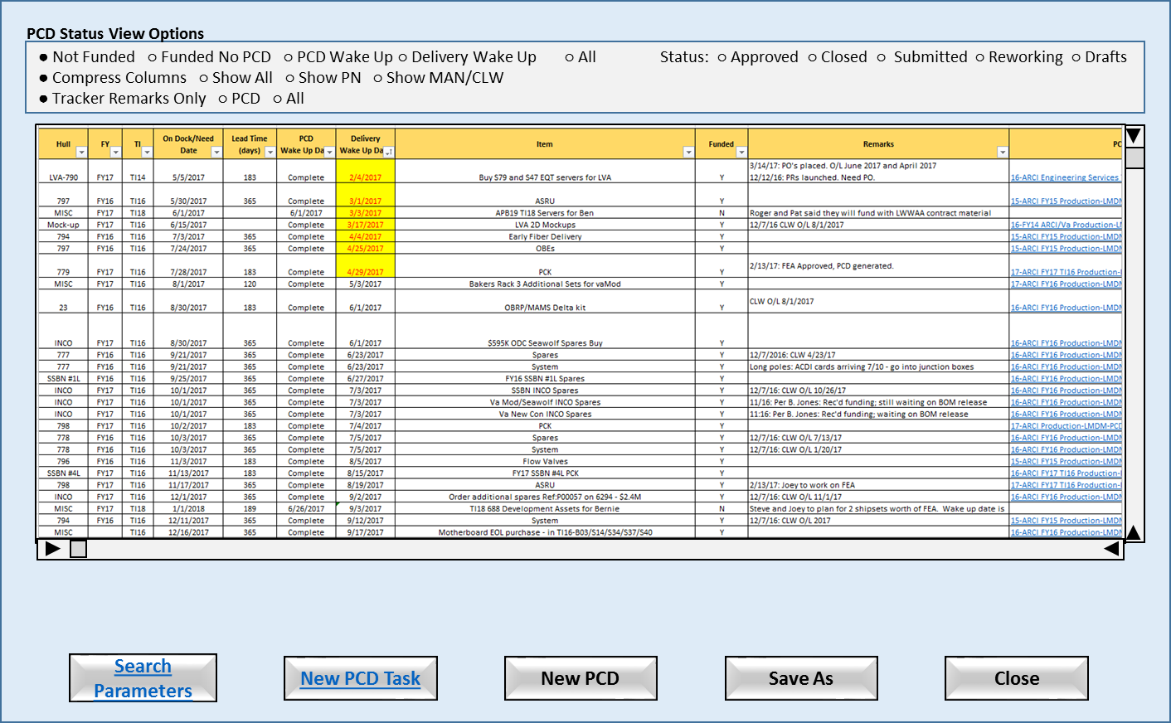

Figure ‑: Status Summary

* Search Parameters: Allows to enter custom parameters to search PCD tracker records.
* New PCD Task: Allows the user to start a new PCD tracker into the system.
* New PCD: Allows the user to start a new PCD that does not tasks.
* Save As: Allows the user to save the contents of the data panel to a file.
* Close: Close the application.

### Requirements

1. The system will support concurrent user inputs/updates.
2. The system will provide ‘spreadsheet’ functionality where practical.
3. The system will highlight data values for the users that violate the business rules.
4. The system will allow the user to view the source data record using the “Tracker Data View” HMI by selecting a record from the “Status View”.
5. The system will allow the user to filter the remarks to include only tracker remarks, PCD remarks, or all remarks.
6. The system will allow the user to add a new PCD task.
7. The system will allow the user to search for PCD tasks using user provided search parameters.
8. The system will automatically provide the required scroll bars if the data exceeds the size of the display panel.
9. The system will allow the user to sort the contents of the display panel.
10. The system will allow the user to save the contents of the display panel to a file.

### Business Rules

1. When the PCD Wakeup date is before or is the same as the current date, the PCD Wakeup date cell will be highlighted in yellow.
2. Any changes to a PCD with an “approved” status will trigger the creation of a revision PCD.

### Functions

1. Search Filter
2. Enumeration Value Helper
3. f_remarks_string – Prototype view that requires the id of the tracker record. May need to be expanded to handle ‘PCD only remarks’ or ‘all remarks’.

### Data Objects

1. Table 7‑1: Trackers
2. Table 7‑2: Program Control Directives (PCD)
3. Table 7‑5: Remarks

### Views

1. No Filters
2. Not Funded (FY: active, PCD: active, Funded: N) (Compress)
3. Funded No PCD (FY: active, PCD: active, Funded: Y) (Compress)
4. PCD Wake Up (Order by PCD Required Date descending) (Compress)
5. Delivery Wake Up (Order by Del Required Date descending) (Compress)
6. End-of-Life
7. Search (user supplied search parameters) (Show All)
8. Approved (Status: approved) (Show All)
9. Closed (Status: closed) (Show All)
10. Submitted (Status: submitted) (Show All)
11. Reworking (Status: rework) (Show All)
12. Drafts (Status: draft) (Show All)

### Complexity

|  | Count |
| --- | --- |
| Inputs | 18 |
| Outputs | 3 |
| Inquires | 4 |
| Files/Tables | 8 |
| Ext. Files | 0 |
| Total: | 33 |

### Implementation

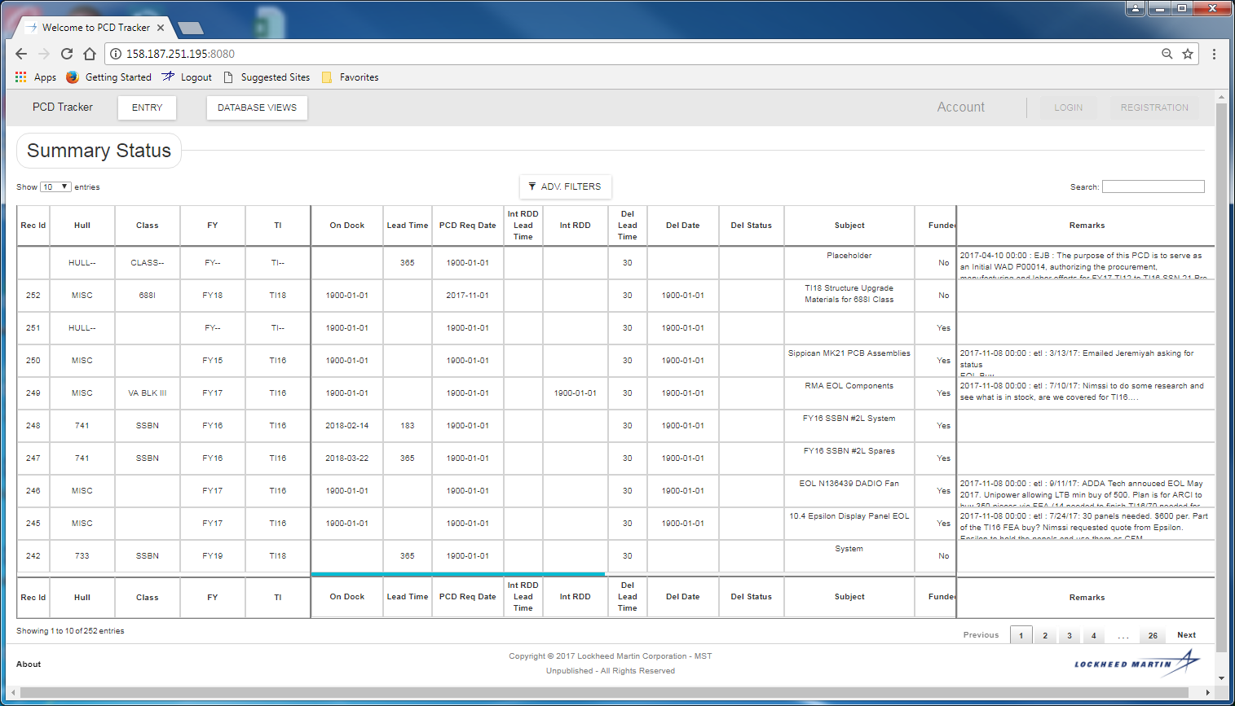

Figure ‑: Summary Status

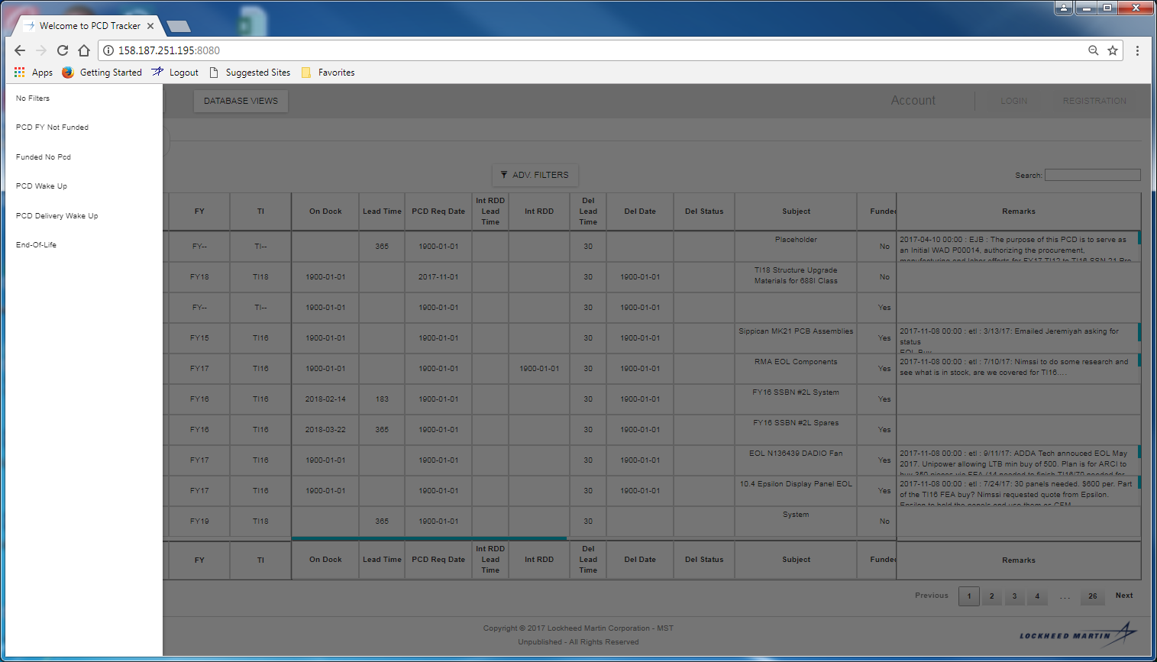

Figure ‑: Advanced Filters Selection for Summary Status

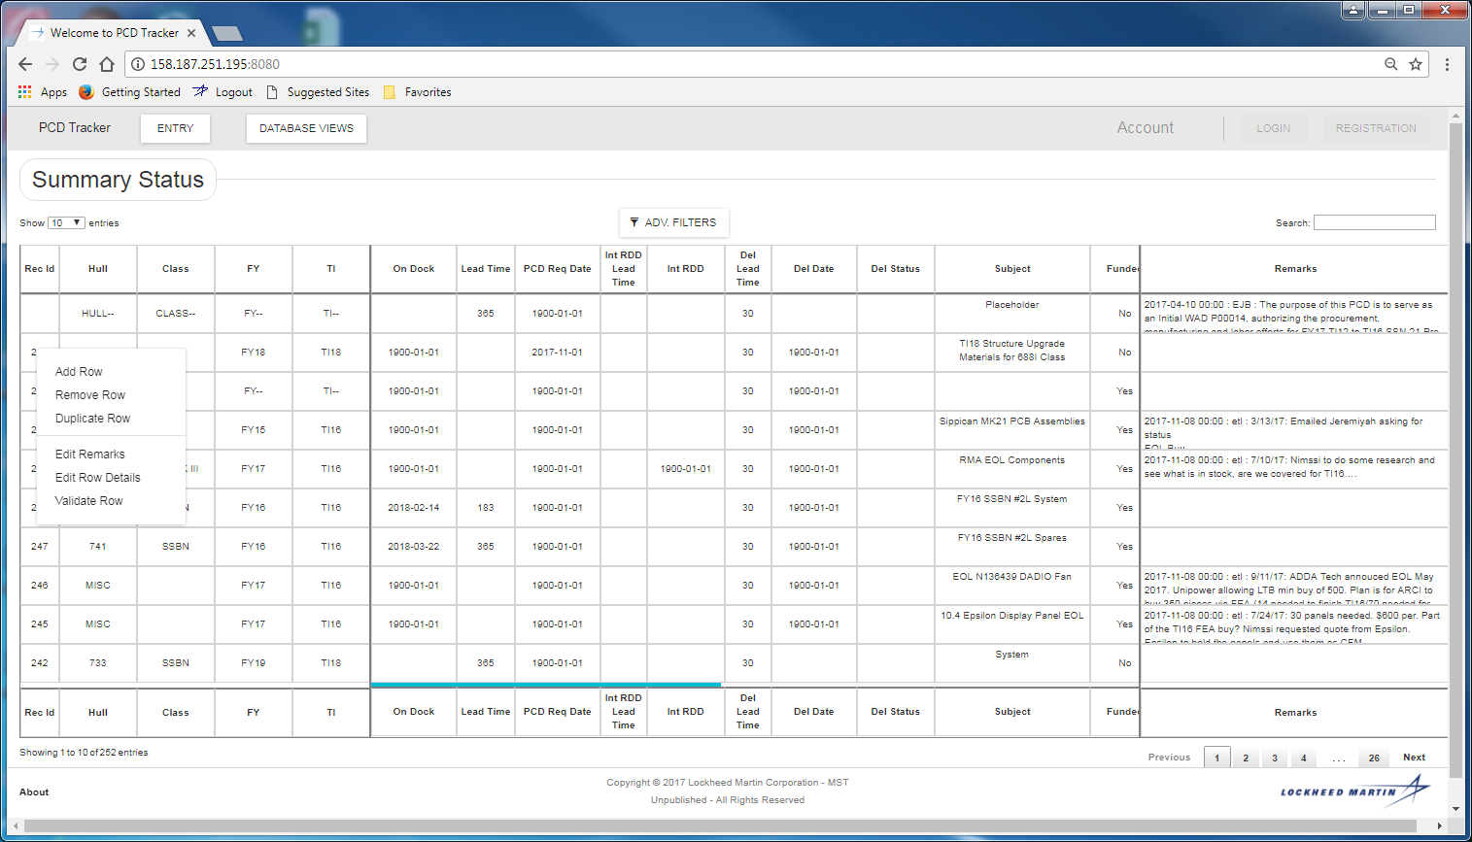

Figure ‑: Right Functions for Summary Status

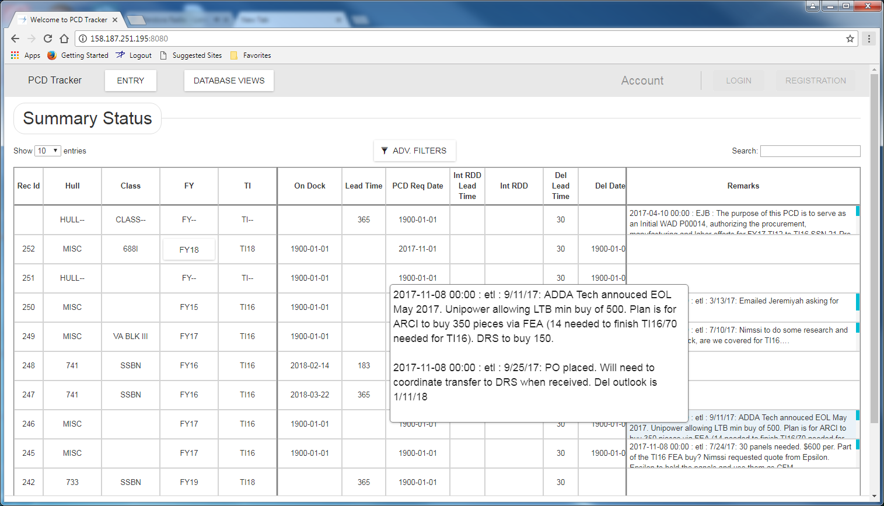

Figure ‑: Remarks Magnification

## Remarks Entry

### Human Machine Interface

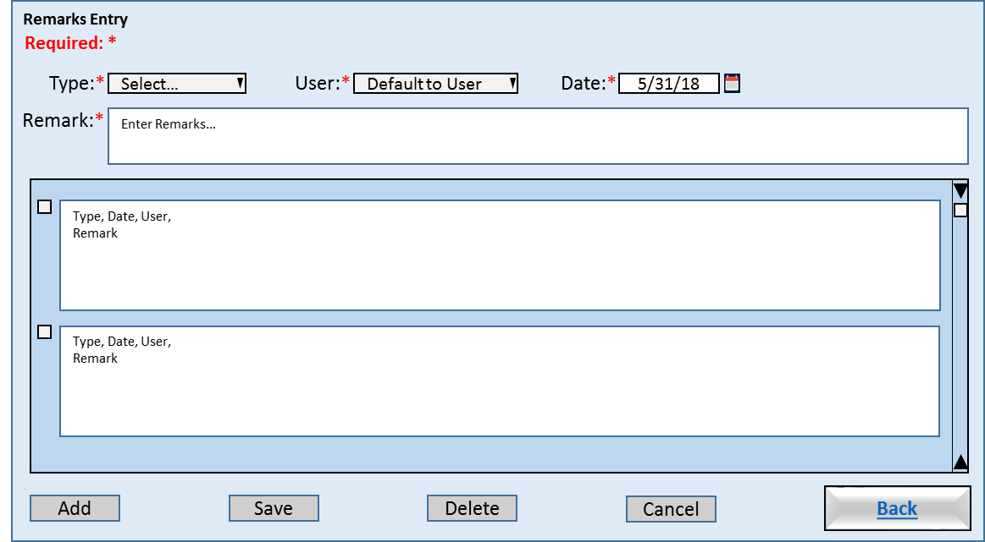

Figure ‑: Remarks Entry

### Requirements

1. The system will support the filter of remarks by type (tracker, pcd, ...).

### Business Rules

### Functions

### Data Objects

### Views

### Complexity

### Implementation

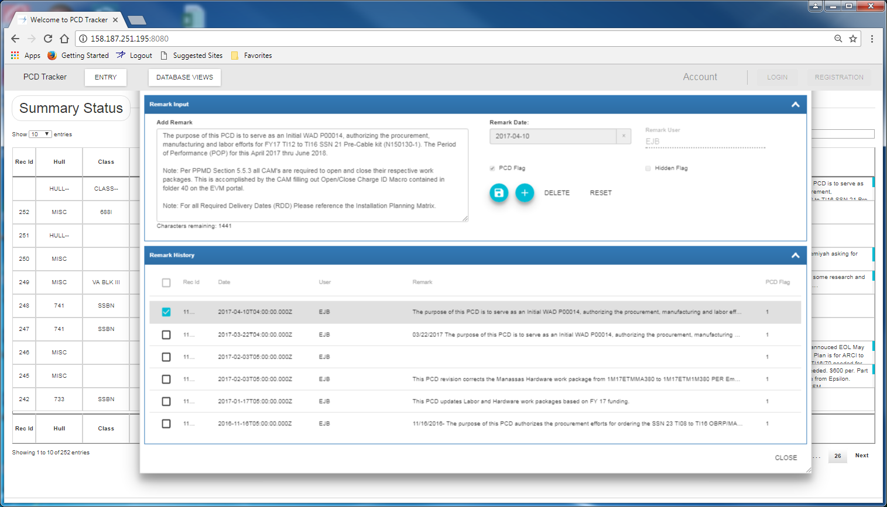

Figure ‑: Remark Input

## Feedback Entry

### Human Machine Interfaces

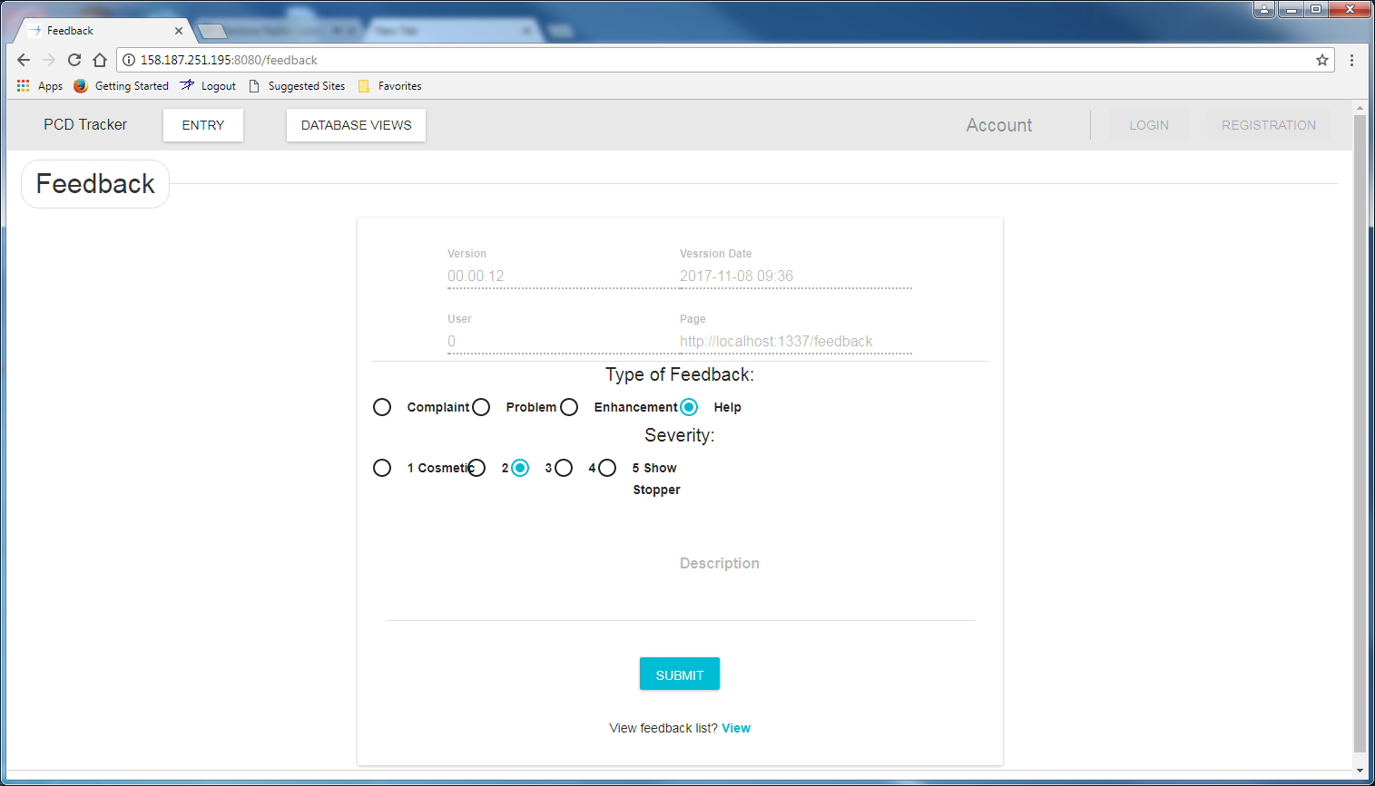

Figure ‑: Feedback Entry

### Requirements

### Business Rules

### Views

### Functions

### Data Objects

### Enumerations

### Complexity

|  | Count |
| --- | --- |
| Inputs | 0 |
| Outputs | 0 |
| Inquires | 0 |
| Files/Tables | 0 |
| Ext. Files | 0 |
| Total: | 0 |

### Implementation

## PCD Tracker Entry

This HMI allows the user to enter and/or update common information needed for a related set of tasks. The user can add and/or delete remarks regarding the activity from this HMI. These remarks will be included in the draft PCD where the user can choose to exclude the remarks from the PCD submission. The “defined fields” allows the user to add program specific terms.

The “tasks” panel provides an area where the user can view sub-tasks related to the PCD. These are tasks that require completion before the PCD can be submitted. This allows management to be able to track the PCD development a finer level of detail. The “task maintenance” button provides the user access the “PCD Tracker Maintenance” HMI. When the user exits the “task maintenance” function the system will refresh the “tasks” panel.

The “material List” button provides the user with the functionality need to create a material List for PCD from the PCD application. Changes to the material List would cause the system version the PCD. Human Machine Interfaces.

Xxxxxx-ARCI-FY-TI-SEQ#

The “copy” button includes copying the tasks.

Sort/filter for tasks?

### Human Machine Interface

#### PCD Tracker Entry (Blank)

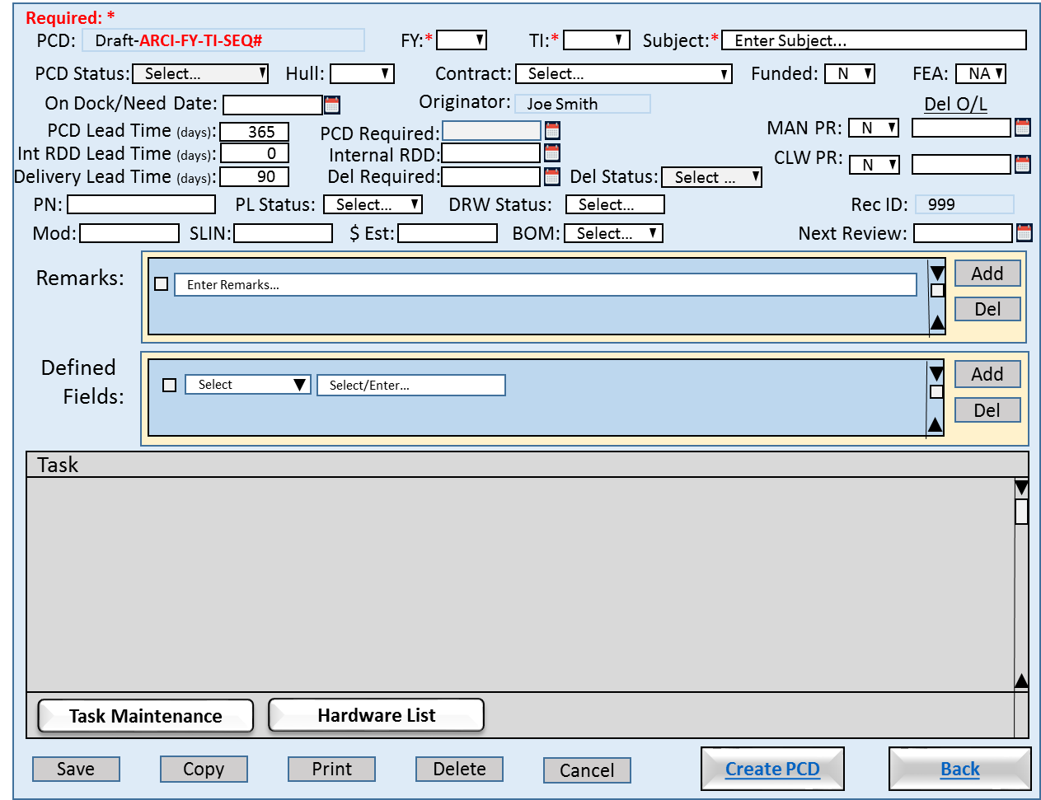

Figure ‑: PCD Tracker Entry (Blank)

* Save: Allows the user to save their changes made to the tracker entry. The system will trigger the creation of a required audit records. “Task Maintenance” and “Material List” have their own save functions.
* Copy: Allows the user to select an existing tracker entry and use it to pre-populate a new entry. The system will include all associated task data. (Need a save as function. The user would need to change either FY, TI or Subject to prevent a duplicate entry error.)
* Print: Allows the user to view a printer ready version of the PCD, and print the PCD.
* Delete: Allows the user to delete the “draft” PCD. The system will flag the entry as deleted and hide the entry from most searches, but the record will be retained by the system for audit purposes.
* Cancel: Allows the user to reset the view to the values at existed upon open the HMI.
* Create PCD: Allows the user to generate a PCD using the data entry into and/or associated with the tracker entry. Upon the initial generation the system will use all data associated with the entry. If the user choose the exclude tasks, remarks, attachments, etc. from the draft PCD, the system will flag those items from future re-generations of the PCD. (So we need a function to add them back in?) The system will trigger the creation of required audit records. The system will open the “PCD” view upon completion.
* Back: Returns to the “Status Summary”.

##### Requirements

1. The system will allow the <users> to add, update and remove <tasks>.
2. The system will allow only the <authorized users> to add and/or delete <remarks>.
3. The system will allow the <users> to copy an existing <tracker> into a new <tracker>.
4. The system will allow the <users> to generate a <draft PCD> from the related <tasks>.
5. The system will show the status of the PCD.
6. The system will allow the <user> to view all the tasks the have been assigned to the <tracker>.
7. The system will allow only the <authorized users> to edit and/or delete a <tracker>.
8. Upon delete of a <remark> the system will flag the <remark> record as logically deleted.
9. Upon delete of a <defined field> the system will flag the <defined field> record as logically deleted.
10. Upon delete of a <material List> the system will flag the <material List> record as logically deleted

##### Business Rules

1. The date required can be no early than the current date.
2. When a new <PCD> is requested the <PCD identifier> is populated with a <draft PCD identifier>.
3. The <draft PCD identifier> will be updated with <PCD> identifier upon <PCD> approval.
4. The <PCD status> will default to ?????.
5. The <FY> is a required field and will default to blank.
6. The <FY> will be selected from the active values contained in the <FY> enumeration list.
7. The <TI> is a required field and will default to blank.
8. The <TI> will be selected from the active values contained in the <TI> enumeration list.
9. The <subject> is a required field and will default to “Enter Subject…”.
10. The <subject> will accept any string except “Enter Subject…” as valid input.
11. The <hull> will default to blank.
12. The <hull> will be selected from the active values contained in the <hull> enumeration list.
13. The <contract> will default to <blank>.
14. The <contract> will be selected from the active values contained in the <contract> enumeration list.
15. The <funded> will default to "N" until selected by the <project manager>.
16. The <fea> identifier will default to "NA" until selected by the <project manager>.
17. The <contract> is a required field and will default to <blank>.
18. The <originator> will default to the individual who created the <draft PCD>.
19. The <on dock/need date> will default to <blank> until entered by the <project manager>.
20. The default <PCD lead time> is 365.
21. Upon modification of the <PCD required date> by the user the system will recalculate the <PCD lead time>.
22. The <PCD lead time> will greater than or equal to 0.
23. The <PCD lead time> will validated against the active values contained in the <PCD lead time> enumeration list. Non-standard values will be confirmed with the user.
24. The <PCD required date> default value is <on dock/need date> minus <PCD lead time>.
25. The default <delivery lead time> is 90.
26. Upon modification of the <delivery required date> by the user the system will recalculate the <delivery lead time>.
27. The <delivery lead time> will greater than or equal to 0.
28. The <delivery lead time> will validated against the active values contained in the <delivery lead time> enumeration list. Non-standard values will be confirmed with the user.
29. The <delivery required date> default value is <on dock/need date> minus <delivery lead time>.
30. The default <internal lead time> is 0.
31. Upon modification of the < internal required date> by the user the system will recalculate the <internal lead time>.
32. The <PCD rdd> cannot be later than or the same as the <internal rdd>.
33. The <internal rdd> date cannot be later than or the same as the <on dock/need date>.
34. The <internal rdd> identifier will default to <blank> until entered by the <project manager>.
35. The < internal rdd > default value is <on dock/need date> minus < internal lead time>.
36. The <man pr> Manassas purchase requisition default is false.
37. The <man del o/l> Manassas delivery date outlook is blank.
38. The <clw pr> Clearwater purchase requisition default is false.
39. The <clw del o/l> Clearwater delivery date outlook is blank.
40. The <pn> will
41. The <pl status> identifier will default to <blank> until selected by the <project manager>. Enumeration Type: Approval (blank, Pre-Release, Released)
42. The <dwg status> identifier will default to <blank> until selected by the <project manager>. Enumeration Type: Approval (blank, Pre-Release, Released)
43. The <mod> identifier will default to <blank> until selected by the <project manager>.
44. The <slin> identifier will default to <blank> until entered by the <project manager>.
45. The <$est> will default to <blank> until entered by the <project manager>.
46. The <bom> identifier will default to <blank> until selected by the <project manager>. Enumeration Type: Approval (blank, Pre-Release, Released)
47. The <rec id>
48. The <next review>

### Implementation

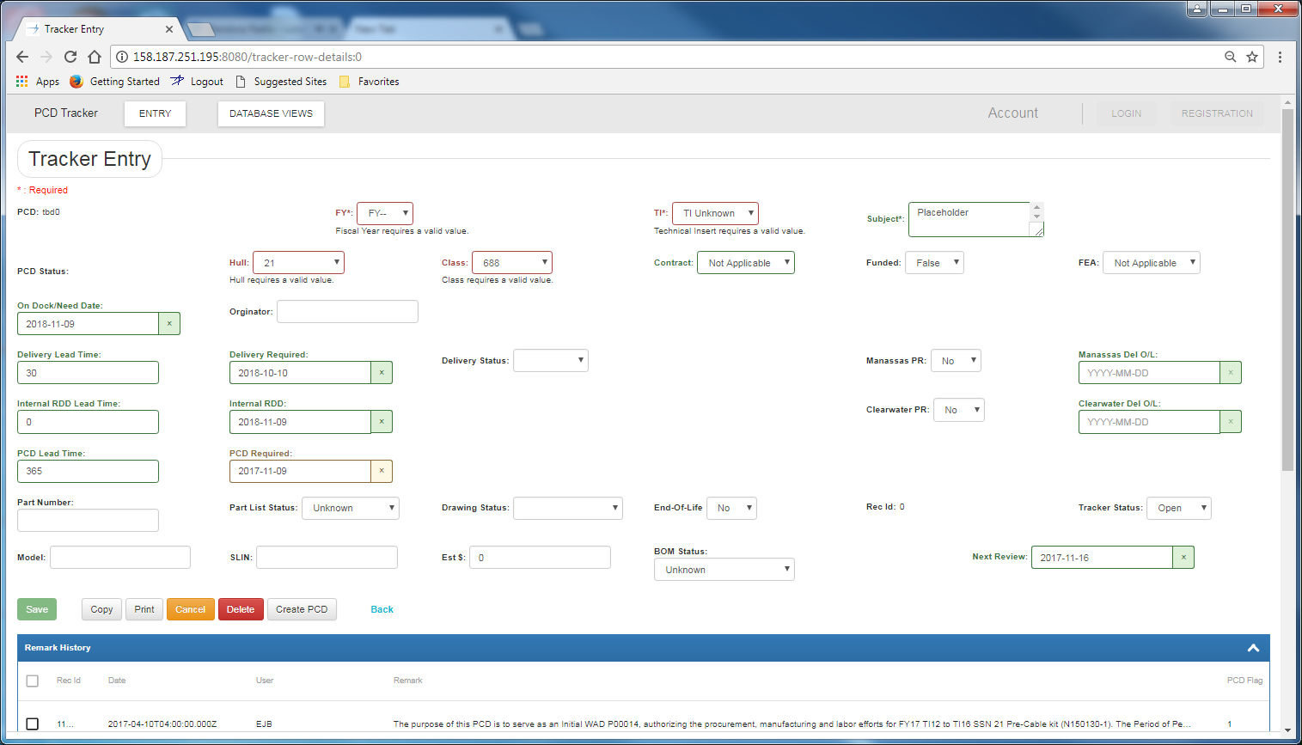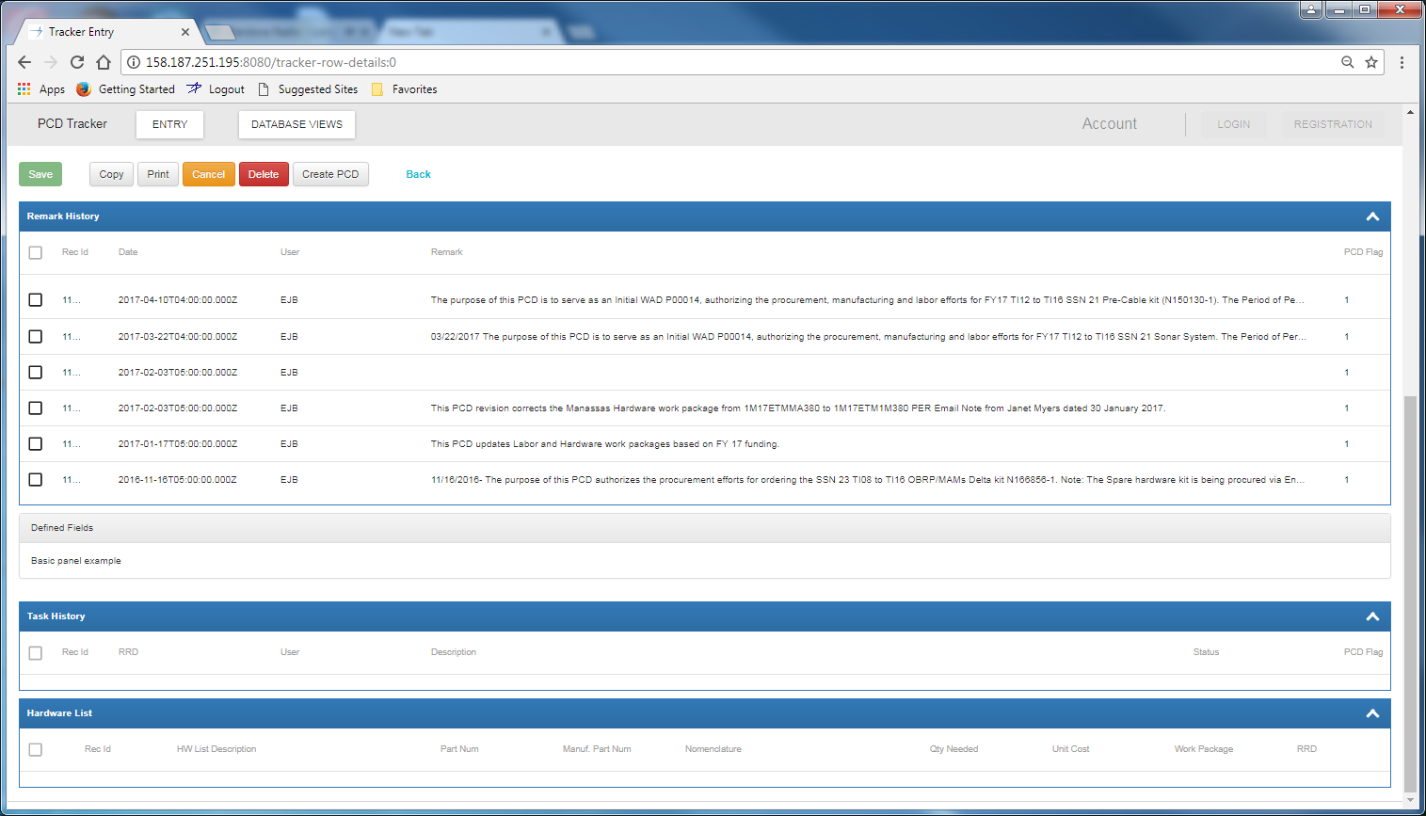

Figure ‑: Tracker Entry

#### PCD Tracker Entry (Populated)

This is the “PCD Tracker Data View” HMI. When the user clicked on the hyperlink in the “Status Summary” HMI the system open this view for the user. The view contains all the information displayed in the status row. (See PCD Tracker Entry for more details.)

When the user edits a “remark” a audit record will be generated.

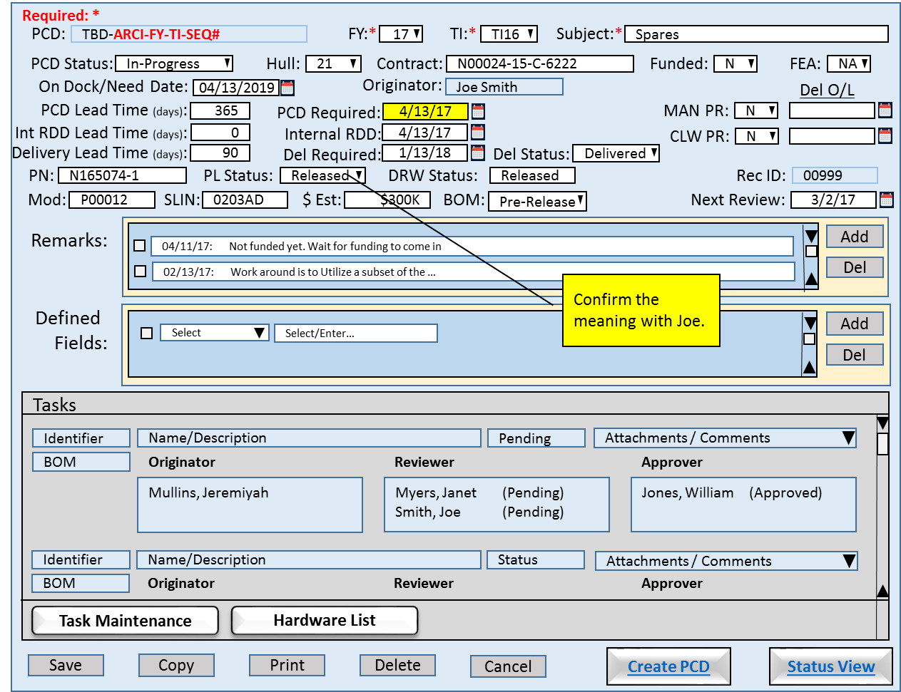

Figure ‑: PCD Tracker Entry (Populated)

#### Requirements

1. The system will allow the user to save the data to Excel.
2. The system will allow the user to print the data.

#### Business Rules

### Functions

1. Contract Selector
2. Enumeration Helper
3. Calendar

### Data Objects

1. Table 7‑1: Trackers
2. Table 7‑2: Program Control Directives (PCD)
3. Table 7‑5: Remarks
4. Table 7‑8: Contracts

### Enumerations

1. FY
2. TI
3. PCD Status
4. Hull
5. Contract
6. T/F (Funded, MAN PR, CLW PR)
7. FEA
8. Users (originator)
9. Status Delivery Part Number
10. Part List Status
11. Drawing Status
12. Mod
13. SLIN
14. BOM
15. Defined Fields
16. Task Type (blank, PN, DWG, DOM, PCD, PR)

### Complexity

|  | Count |
| --- | --- |
| Inputs | 18 |
| Outputs | 3 |
| Inquires | 4 |
| Files/Tables | 8 |
| Ext. Files | 0 |
| Total: | 33 |

## PCD Tracker Maintenance

The HMI will allow the authorized user to add, update, delete, and close tasks. The user will entered the required minimum information for the task type. The user can add and/or delete attachments and remarks regarding the activity from this HMI. These remarks will be included in the draft PCD where the user can choose to exclude the remarks from the PCD submission. The HMI contains a scrolled task panel that displays tasks already entered for the associated tracker entry. When the user selects a existing tasks by checking the tack, and clicking on the “Edit” button the this will populate the entry/edit form on the top of the page.

For the originator, reviewer, and approver inputs, the system will display a list of individuals where the user can select one or more individuals to add them to role.

The user can add attachments to the task by clicking on the “Add” button. The system will open a separate window where the user will search for and select the external file from. When the user selects a attachment(s) using the check box, the “View” and “Delete” buttons will be enabled. (The check box default state is unchecked.) When the “View” button is clicked the system will open a separate window and display the document. When the “Delete” button is clicked the system will remove the attachment(s) from the task. The attachment entry will be retained by the system with a “hidden” status for audit purposes. These attachment(s) will be included in the draft PCD where the user can choose to exclude the attachment(s) from the PCD submission.

The user can add and/or delete remarks regarding the task from this HMI. When the user selects a remark(s) using the check box, “Delete” buttons will be enabled. (The check box default state is unchecked.) When the “Delete” button is clicked the system will remove the remark(s) from the task. The remark entry will be retained by the system with a “hidden” status for audit purposes. These remark(s) will be included in the draft PCD where the user can choose to exclude the remark(s) from the PCD submission.

### Human Machine Interfaces

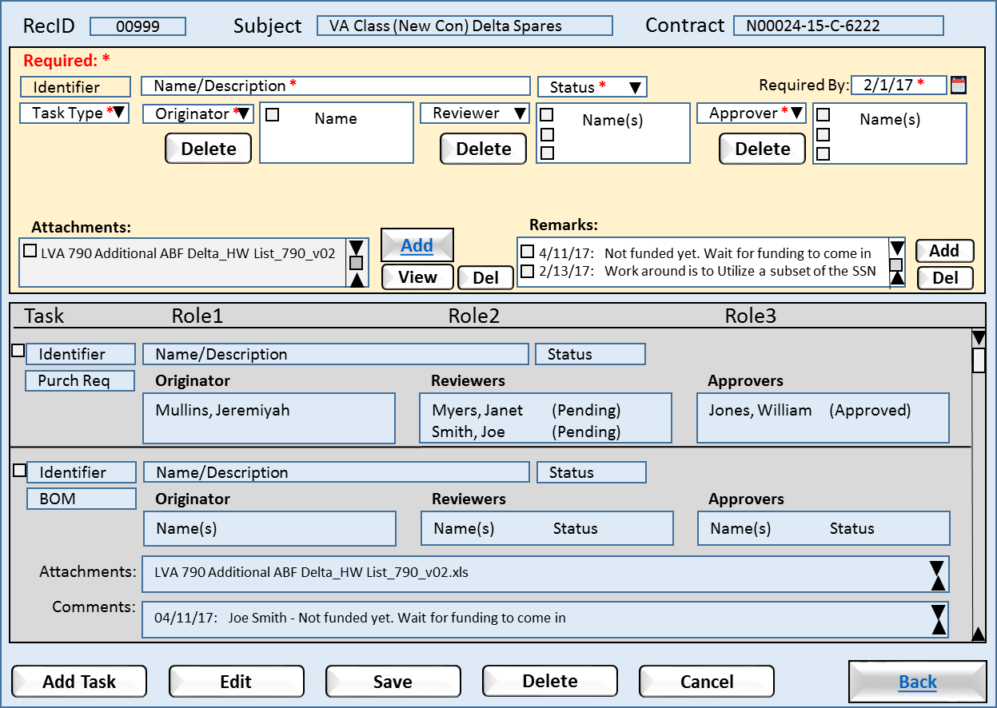

Figure ‑: PCD Tracker Maintenance

* Add: For the attachments it allows the user to attach a external document for the task.
* Delete: For the originator, reviewer, and approver roles, allows the user to remove an individual from the role for the task.
* View: For the attachments it allows the user to view the attachment selected.
* Delete: For the attachments and remarks fields, allows the user to remove elected items from the task.
* Add Task: Allows the user to enter a new task under the tracker entry. The system will initialize the input panel to its default state. The system will enable the “Save” button when all the required fields are entered.
* Edit: When the user selects a task from the task panel the system will enable the “Edit” button. When the user clicks the “Edit” button the system will populate the task edit panel and the allow user to update the task.
* Save: Allows the user to save their changes made to the task entry. The system will trigger the creation of required audit records. “Task Maintenance” and “Material List” have their own save functions. (Audit details)
* Delete: Allows the user to delete the “draft” PCD. The system will flag the entry as deleted and hide the entry from most searches, but the record will be retained by the system for audit purposes.
* Cancel: Allows the user to reset the view to the values at existed upon open the HMI.
* Back: Returns the user to the HMI that the current HMI was called from.

### Requirements

1. The system shall automatically assign item identifiers that are unique.
2. The system shall validate that all required fields are complete.
3. The system shall allow the <authorized user> to maintain the enumerations used in the drop-down list boxes.
4. The system shall use the <active directory> to assign individual tasks.

### Business Rules

1. A required roles needs to have at least one individual assigned.
2. The <Required By> date cannot be later than or the same as the <Internal RDD> date.

### Functions

1. Calendar
2. Action Person Helper
3. Approver Person Helper
4. Enumeration Helper
5. Attachments
6. Notes?

### Data Objects

1. Table 7‑1: Trackers
2. Table 7‑2: Program Control Directives (PCD)
3. Table 7‑5: Remarks
4. Table 7‑6: Tasks
5. Table 7‑10: Attachments
6. Table 7‑12: Enumeration Values

### Enumerations

1. Status Tracker
2. Task Type
3. Users (Originator, Reviewers, Approvers)

### Complexity

|  | Count |
| --- | --- |
| Inputs | 11 |
| Outputs | 1 |
| Inquires | 7 |
| Files/Tables | 6 |
| Ext. Files | 1 |
| Total: | 26 |

## PCD Material List Entry

This HMI allows the user to construct a material List. The basic HMI has three inputs:

1. The material List
2. Remarks
3. Attachments

The four buttons on the bottom of the HMI permit the user to save a list being work, submit for approval, or cancel any changes that had been contacts, or remarks.

When the user has prepared the material List outside the PCD, the user will import the external document as an attachment(s).

The panel in the center of the HMI is where the user constructs the material List. When the HMI opens any parts previously entered would be displayed. When the user clicks on the Add button a new line will be created for the user to complete. When the Add button is clicked any changes/additions to the list will saved. When a value has been entered into a new line the “Save” button will be enabled.

If the user needs to delete a line(s), the user would select the line(s) and then click the Delete button. Until user selects a material List entry the “Delete” button would be disabled.

The select of a material List entry or entries will enable the “Group By” button. The “Group By” allows the user to assign an identifier to those entries. As shown in the HMI the user select the “sonar laptop” entry and assigned it to the “Hardware” group, and repeated the action to create a “Software” group. Does the group need a checkbox? The HMI will refresh to reflect the user grouping automatically. To remove a material List entry from a group the user would select the entry and assign it to the “” group which is the default group for all entries.

Cancel?

### Human Machine Interfaces

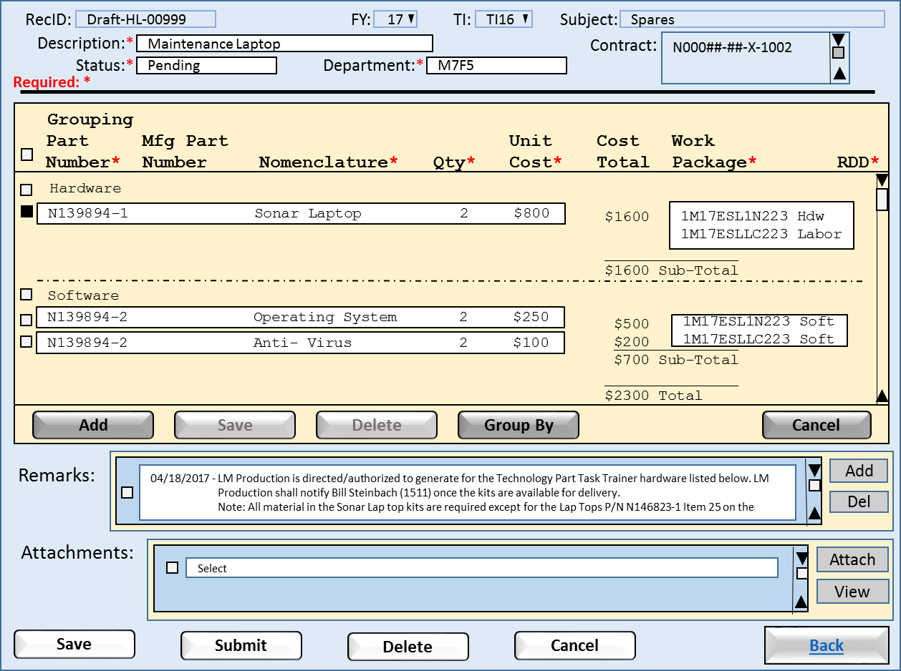

Figure ‑: PCD Material Entry List

1. Add: The system will add a blank line item for the user to complete.
2. Save: Allows the user to save an added or updated line item.
3. Delete: The system will delete those line item(s) the user has selected for removal. (Audit details)
4. Group By: The system will group line item(s) the user has selected. (How do we ungrouped items?)
5. Cancel: Allows the user to reset the line items to the values at existed upon open the HMI.
6. Save: Allows the user to save their changes made to the task entry. The system will trigger the creation of required audit records. “Task Maintenance” and “Material List” have their own save functions. (Audit details)
7. Submit: Allows the user to submit the material List for review.
8. Delete: Allows the user to delete the “draft” material List. The system will flag the entry as deleted and hide the entry from most searches, but the record will be retained by the system for audit purposes.
9. Cancel: Allows the user to reset the view to the values at existed upon open the HMI.
10. Back: Returns the user to the HMI that the current HMI was called from.

### Requirements

1. Upon saving of the material List entry, the system will check for empty/null required fields and if found the system will prompt the user to completed entry of required fields.
2. If unsaved changes exist prior to closing the HMI, the system will prompt the user to save the changes.
3. If unsaved changes exist prior to cancel a session, the system will warn the user that changes will be lost.
4. Before deleting a part(s) the system will prompt the user for confirmation.

### Business Rules

1. The Submit button will be enabled when either one part is added, or a attachment has been made.
2. When the Submit button is clicked the system will forwarded the to the reviewers/approvers.
3. When all the reviewers/approves have approved the material List, the list will be forwarded to the purchasing contacts.
4. An approved Material List will be locked to prevent additional part list changes.
5. An approved Material List will need approver to submit the part list for rework for changes to be made to the part list.
6. ??? Change history

### Functions

1. Directory Helper
2. Attachments
3. Remarks
4. Material List

### Data Objects

1. Table 7‑3: Material Lists
2. Table 7‑4: Material List Items
3. Table 7‑5: Remarks
4. Table 7‑6: Tasks
5. Table 7‑10: Attachments

### Enumerations

1. Status Material List
2. Departments

### Complexity

|  | Count |
| --- | --- |
| Inputs | 10 |
| Outputs | 3 |
| Inquires | 1 |
| Files/Tables | 3 |
| Ext. Files | 1 |
| Total: | 18 |

## PCD Draft

This HMI shows the results of the user from having clicked the “Create PCD” button on the “PCD Tracker Entry” HMI. The data elements from all PCD tasks combined together in their respective sections. This the last sentence true, or is select sections? The HMI includes the functionality for the user to be able expand/collapse any given section. All the section are collapse when HMI opens. The user can click on the “+” symbol to expand a section. The section will resize the section and page to fit the data elements. The “+” symbol will change to a “-” symbol. Clicking a “-” will collapse the section and resize page. Should the user choose to add a data element to a section that is collapsed, the section will automatically expand.

The user has the functionality to edit each of the sections prior to the PCD submission. When the HMI opens only the “Add” buttons will be enabled. Depending on the section, when a data element is selected by the user using the checkbox the “Delete” and “View” are enabled. Deselecting the data element disable the buttons.

### Human Machine Interfaces

#### PCD Draft (Collapsed)

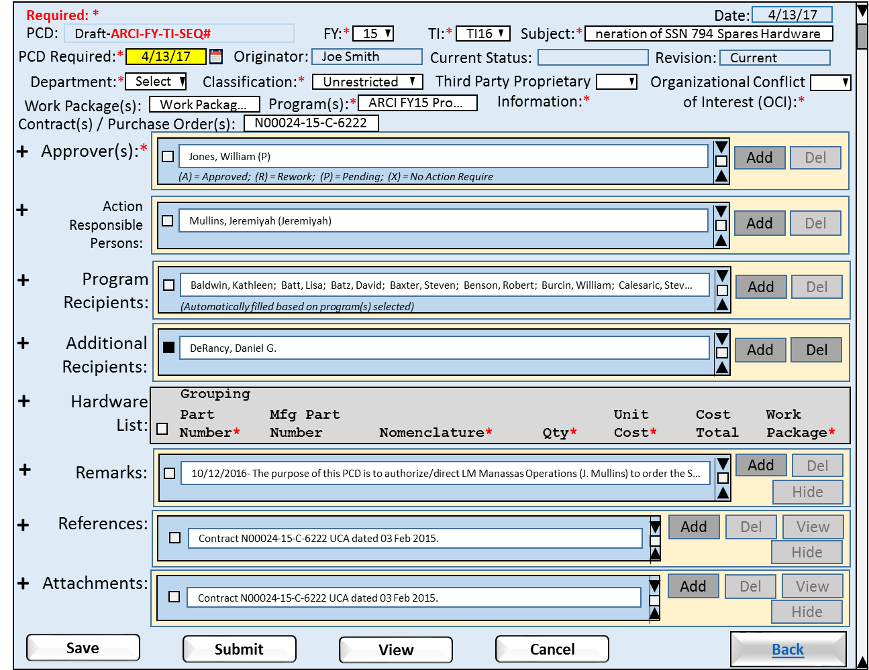

Figure ‑: PCD Draft (Collapsed)

1. Add: Allows the user to insert additional items into the PCD.
2. Delete:
3. View: For the attachments it allows the user to view the attachment selected.
4. Hide/Unhide:
5. Save: Allows the user to save their changes made to the task entry. The system will trigger the creation of required audit records. “Task Maintenance” and “Material List” have their own save functions. (Audit details)
6. Submit: Allows the user to submit the PCD for review.
7. View: Allows the preview how the PCD will look when printed.
8. Cancel: Allows the user to reset the line items to the values at existed upon open the HMI.
9. Back: Returns to the “Status Summary”.

##### Requirements

1. The system will allow the user to collapse a expanded section.
2. The system will allow the user to expand a collapsed section.
3. The system will allow the user to collapse all sections with a single click.
4. The system will allow the user to expand all sections with a single click.
5. If unsaved changes exist prior to closing the HMI, the system will prompt the user to save the changes.
6. If unsaved changes exist prior to cancel a session, the system will warn the user that changes will be lost.

##### Business Rules

1. Upon the user adding a new data element to a section the System will associate and stored the data element with PCD.
2. Upon user change to an existing element in a section the System will update the source data element in the respective section and task.
3. Upon clicking the “Submit” button the system will change the PCD status from “Draft” to “Submitted”.
4. Upon clicking the “Submit” button the system will notify the reviewer(s)/approver(s) that the PCD is available for review.

#### PCD Draft (Expanded I)

In this view of the “Draft PCD” HMI shows all the sections expanded. The page size will automatically expand to fit the data elements.

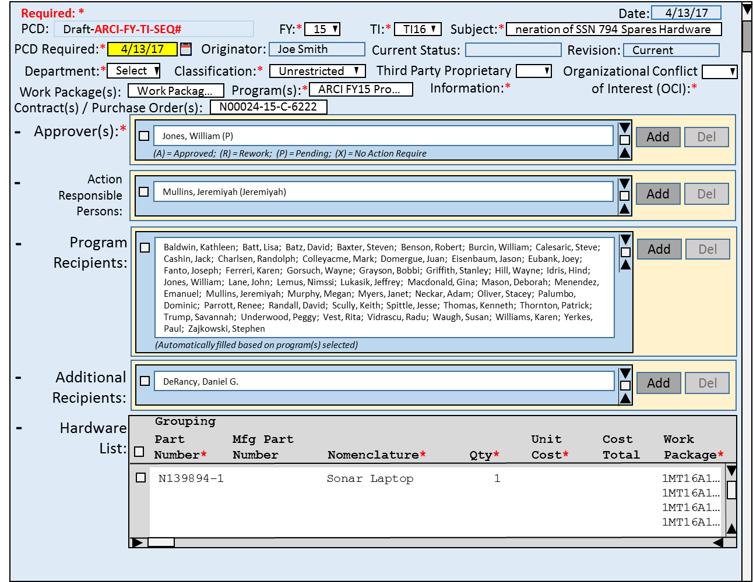

Figure ‑: PCD Draft (Expanded I)

##### Requirements

1. If unsaved changes exist prior to closing the HMI, the system will prompt the user to save the changes.
2. If unsaved changes exist prior to cancel a session, the system will warn the user that changes will be lost.

##### Business Rules

1. The Submit button will be enabled when either one part is added, or a attachment has been made.
2. When the Submit button is clicked the system will forwarded the to the reviewers/approvers.
3. When all the reviewers/approves have approved the material List, the list will be forwarded to the purchasing contacts.
4. An approved Material List will be locked to prevent additional part list changes.
5. An approved Material List will need approver to submit the part list for rework for changes to be made to the part list.
6. ??? Change history

#### PCD Draft (Expanded II)

This version of the Draft PCD includes the user functionality to include/exclude data elements within a section from the PCD submission. In the “Remarks” section the user has previously choose the exclude the remark dated 8/19/2015. The HMI indicates that the remark is excluded by graying out the data item display. This tells the user that the remark will excluded from the submitted PCD. Because the remark is excluded and the selection box checked the “Unhide” button is enabled to allow the user to be able to add the remark back into the PCD.

In comparison the “References” section has an item that is selected and the “Hide” button enabled. This allows the user to exclude this item from the PCD if they choose. If the wishes choose to hide the item they would do so by clicking on the “Hide” button, the item would be grayed as show above with the remarks item.

If the user were to alter a “Remark”, the alteration would trigger the creation of a audit record capturing the remark’s pre and post content.

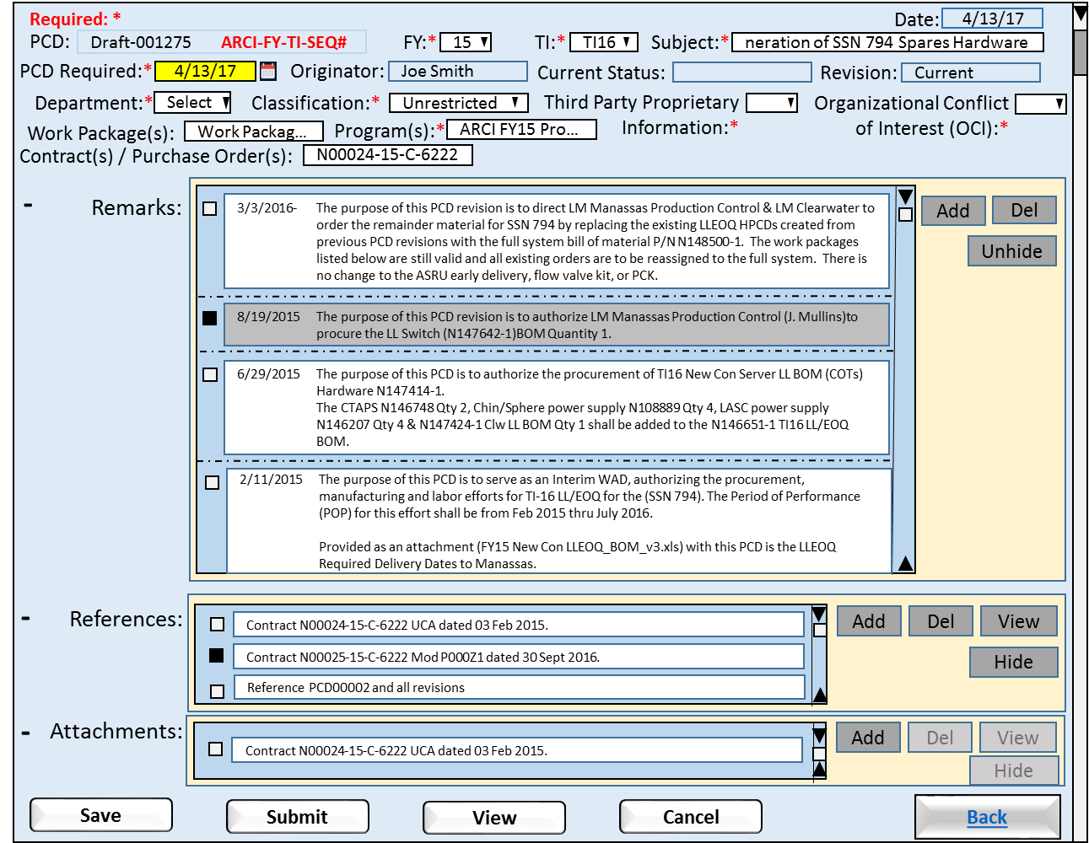

Figure ‑: PCD Draft (Expanded II)

##### Requirements

1. The system will allow the user to select data items to be include/excluded from the PCD submission.
2. The system will gray out excluded items.
3. If unsaved changes exist prior to closing the HMI, the system will prompt the user to save the changes.
4. If unsaved changes exist prior to cancel a session, the system will warn the user that changes will be lost.

##### Business Rules

1. The Submit button will be enabled when either one part is added, or a attachment has been made.
2. When the Submit button is clicked the system will forwarded the to the reviewers/approvers.
3. When all the reviewers/approves have approved the material List, the list will be forwarded to the purchasing contacts.
4. An approved Material List will be locked to prevent additional part list changes.
5. An approved Material List will need approver to submit the part list for rework for changes to be made to the part list.
6. ??? Change history

### Functions

1. Directory Helper
2. Attachments
3. Remarks
4. Material List

### Data Objects

1. Table 7‑1: Trackers
2. Table 7‑2: Program Control Directives (PCD)
3. Table 7‑3: Material Lists
4. Table 7‑4: Material List Items
5. Table 7‑5: Remarks
6. Table 7‑10: Attachments

### Enumerations

1. Users

### Complexity

|  | Count |
| --- | --- |
| Inputs | 0 |
| Outputs | 0 |
| Inquires | 0 |
| Files/Tables | 0 |
| Ext. Files | 0 |
| Total: | 0 |

## PCD Entry

This HMI is intended for the entry of a simple PCDs such as a Delegation of Authority, (DOA). The user will have selected to create a new PCD from the “PCD Status Review” HMI. The “Originator” field will be pre-filled with the id of the individual who clicked the “New PCD” button. The “Add” functions will be the only data entry functions enabled. Once the user was populated a field the “Save” button will be enabled. Once the user was populated the required fields the “Submit”, and “View” buttons will be enabled.

After adding a value to “Approver(s)” section and checking the selection box, the “Delete” function would be enabled. If the user unchecked the selection, or did delete the selection, the “Delete” function would be disabled. The same controls would apply to the sections: Program Recipients, Action Responsible Persons, Additional Recipients, Material List, and Remarks. In case of References and Attachments, the “View” function would work in the same fashion as the “Delete” function.

### Human Machine Interfaces

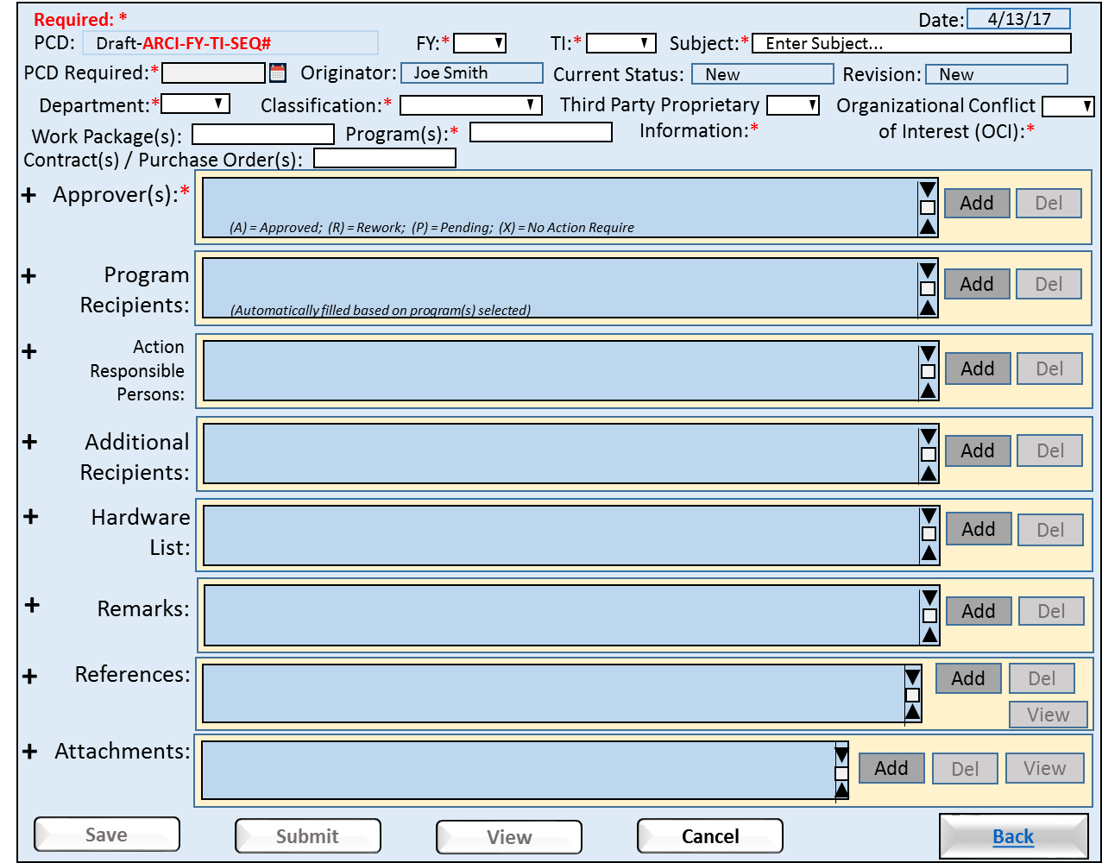

Figure ‑: PCD Entry

1. Save: Allows the user to save their changes made to the task entry. The system will trigger the creation of required audit records. “Task Maintenance” and “Material List” have their own save functions. (Audit details)
2. Submit: Allows the user to submit the PCD for review.
3. View: Allows the preview how the PCD will look when printed.
4. Cancel: Allows the user to reset the line items to the values at existed upon open the HMI.
5. Back: Returns to the “Status Summary”.

### Requirements

1. Upon submission of the PCD the system will check for empty/null required fields and if found the system will prompt the user to completed entry of required fields.
2. If unsaved changes exist prior to closing the HMI, the system will prompt the user to save the changes.
3. If unsaved changes exist prior to cancel a session, the system will warn the user that changes will be lost.

### Business Rules

1. The Save button will be enabled when at least one data field is filled, and disabled when no data fields are filled.
2. The Submit button will be enabled when the required fields are filled, and disabled when a required field(s) are empty/null.
3. When the Submit button is clicked the system will forwarded the to the reviewers/approvers for review.

### Functions

1. Directory Helper
2. Attachments
3. Remarks
4. Attachments

### Data Objects

1. Table 7‑1: Trackers
2. Table 7‑2: Program Control Directives (PCD)
3. Table 7‑3: Material Lists
4. Table 7‑4: Material List Items
5. Table 7‑5: Remarks
6. Table 7‑10: Attachments

### Enumerations

### Complexity

|  | Count |
| --- | --- |
| Inputs | 3 |
| Outputs | 1 |
| Inquires | 11 |
| Files/Tables | 6 |
| Ext. Files | 0 |
| Total: | 21 |

## PCD Generic View

All of the PCD data may be viewed. Attachments can be retrieved, however they cannot be added, modified, or deleted from the PCD itself. The PCD state cannot be changed.

### Human Machine Interfaces

#### (I)

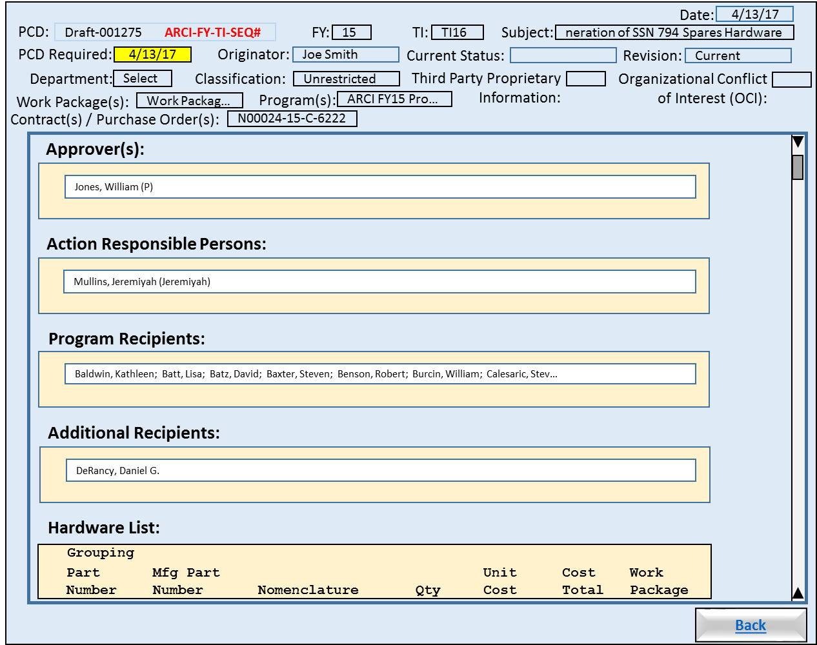

Figure ‑: PCD Generic View (I)

1. Back: Returns to the “Status Summary”.

##### Requirements

##### Business Rules

#### (II)

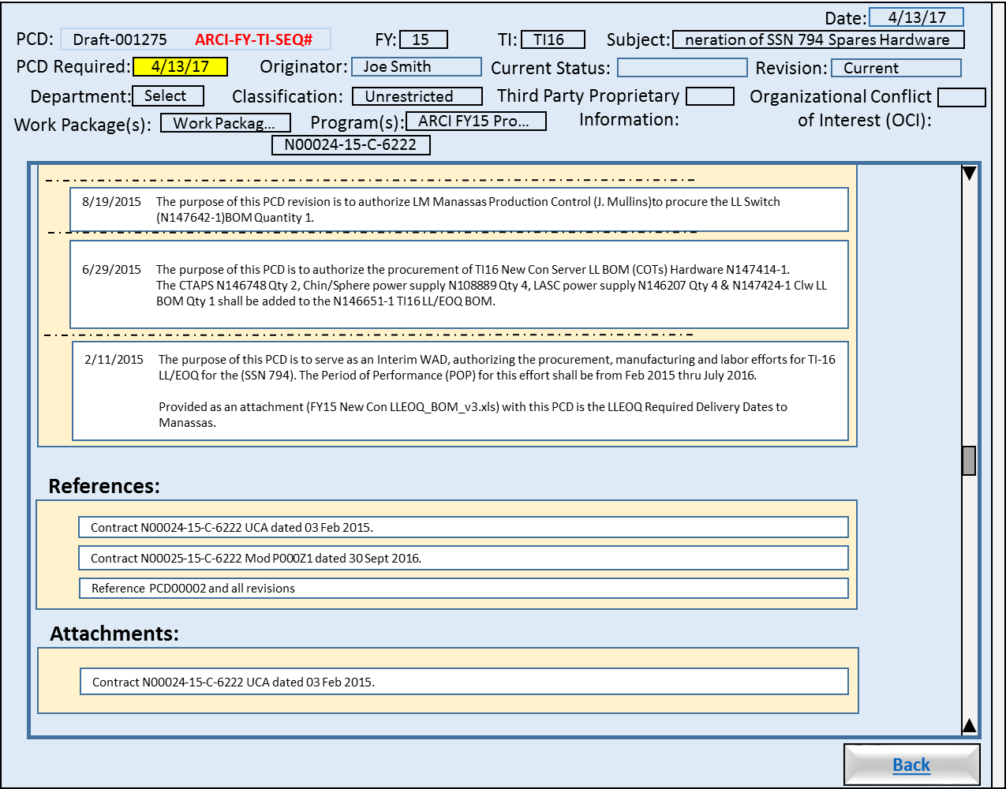

Figure ‑: PCD Generic View (II)

##### Requirements

##### Business Rules

#### Buttons







##### Requirements

##### Business Rules

### Views

### Functions

### Data Objects

* Table 7‑1: Trackers

1. Table 7‑2: Program Control Directives (PCD)
2. Table 7‑3: Material Lists
3. Table 7‑4: Material List Items
4. Table 7‑5: Remarks
5. Table 7‑10: Attachments

### Enumerations

### Complexity

|  | Count |
| --- | --- |
| Inputs | 0 |
| Outputs | 0 |
| Inquires | 0 |
| Files/Tables | 0 |
| Ext. Files | 0 |
| Total: | 0 |

## PCD Status Search / Report Parameters

This HMI provides the user with the ability to define their own PCD search or report criteria. Once the user has completed entering the parameters the user will click on either the “Search” button to execute the search and populate the “Status Summary”, or the “Report” button to execute the search and saves the results to a spreadsheet. If the search fails to find any matching records the system will display a message for the user that no matching records where found. If the search does find matches the system will return the user to the “Status View” HMI and refresh the view with the search results. Clicking the “Clear Search” will set the parameters back to their default values.

When the search button is pressed, the user is presented with a screen where the search criteria are entered. Entering data in any of the search fields indicates that the resulting PCD's must contain that criteria. Wildcards are allowed and are specified using a "*".

Once the search has completed, a list of all resulting PCD's is displayed. Hyperlinks are available to each PCD which allow the user to work with the corresponding PCD in the same manner which is available from the Contracts/Programs option. See Section 4.1 - Contracts/Programs

### Human Machine Interfaces

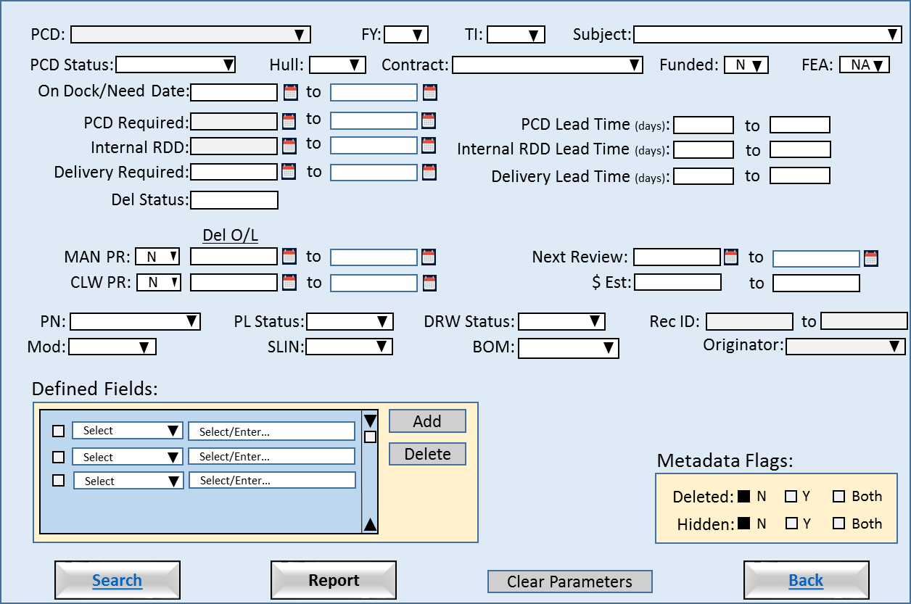

Figure ‑: PCD Status Search / Report Parameters

* Search: Executes a search for PCDs using the user provided parameters.
* Report: Generates a report for PCDs found using the user provided parameters.
* Clear Parameters: Sets the parameters back to their default values.
* Back: Returns to the “Status Summary”.

### Requirements

1. The system will require at 1 search parameter be provided by the user.
2. The system will allow the user to perform wildcards searches.
3. The system will retain the last successfully search parameters.
4. The system will re-populate the parameters using the last successfully search parameters.
5. The system will allow the user rest the search parameters to their default values.

### Business Rules

1. Null search parameters will not be used in the search.
2. Empty strings are valid parameters. (Think about the wording.)
3. The “from” date is less than or equal to the “to” date.

### Functions

1. PCD List
2. Subject List
3. Calendar
4. Search Filter

### Data Objects

1. Table 7‑1: Trackers
2. Table 7‑2: Program Control Directives (PCD)
3. Table 7‑9: Search

### Enumerations

1. FY
2. TI
3. PCD Status
4. Hull
5. Contract
6. T/F (Funded, MAN PR, CLW PR)
7. FEA
8. Delivery Status
9. Part Number
10. Part List Status
11. Drawing Status
12. Mod
13. SLIN
14. BOM
15. Users (Originator)
16. Defined Fields

### Complexity

|  | Count |
| --- | --- |
| Inputs | 24 |
| Outputs | 1 |
| Inquires | 10 |
| Files/Tables | 2 |
| Ext. Files | 0 |
| Total: | 37 |

## [CSC Name] CSC

This section should start with a brief description of the CSC.

### [Function Name]

This section describes a function of the CSC. Each function allocated to the CSC should reside under its own heading, so there may be multiple sections. Test methods can be embedded within the descriptions. If so, place a note in section 2.4 that states the embedded approach.

#### Test Method

This section provides CQT level test description for the function described above.

#### Algorithms (if applicable)

This section should describe any algorithms needed for the SW team to implement.

#### SW Reuse (if applicable)

This section examines the proposed software reuse that was identified during the replan estimation process. (see Alan’s ppt at: <https://www.silcweb.com/silc/?u=bpw>).

#### Requirements Traceability

This section provides a traceability matrix for the SSS and PBS requirements related to the CSC specification.

# PCD Working Modes

The modes are available when working with an individual PCD: Edit, Approve, and View. When a PCD has been selected, the mode in which it’s displayed depends on its state and the authority of the current user. The application picks which mode to open the PCD in based upon the Conditions column of Table 2-1.

Table ‑: PCD Working Modes

| Mode | Conditions | Description |
| --- | --- | --- |
| Edit | Originator or Administrator when PCD is in Draft or Rework state. | Allows entry/modification of the following fields:   * Approver(s) * Associated Contracts * Department * Subject * Distribution Lists * Action Responsible People * Additional Recipients * Reference * Action/Remarks * Programs * Program to Use in PCD Number * Attachments   The PCD can be Saved, Submitted, or Deleted. |
| View | Any user and any PCD in any state (which is not listed for the Edit or Approve modes). | All of the PCD data may be viewed. Attachments can be retrieved, however they cannot be added, modified, or deleted from the PCD itself. The PCD state cannot be changed. |
| Approve | Assigned Approver when PCD is in Submitted state. | Approvers can view the PCD just as in the View mode. In addition they may add/modify their remarks and select to Approve or Rework the PCD. |

# Database Views

## Database View Menu

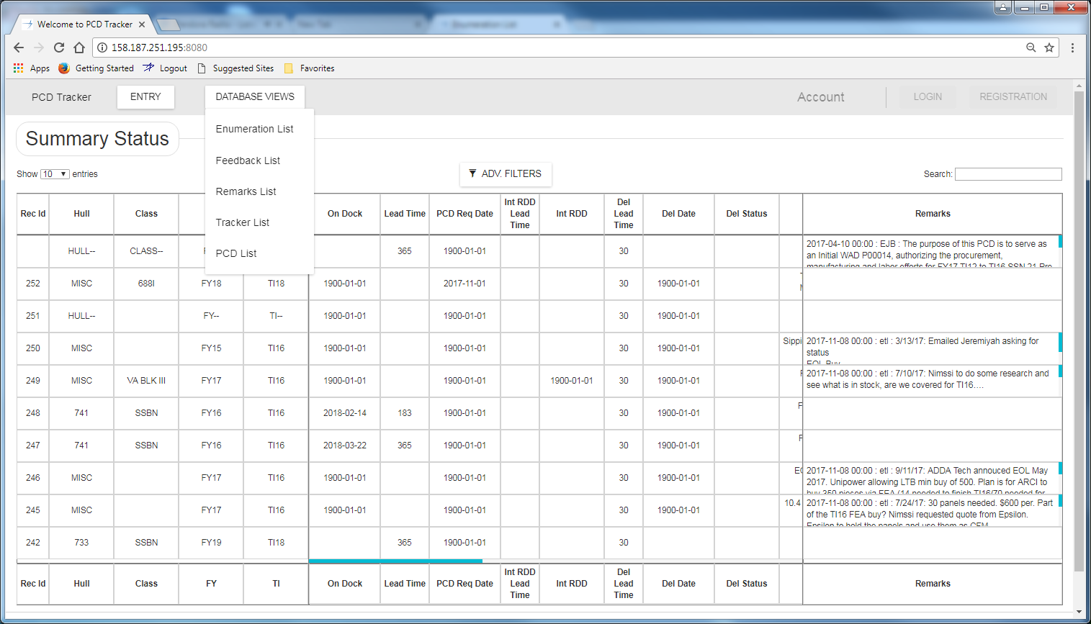

Figure ‑: Database Views Menu

## Enumeration List

### Human Machine Interfaces

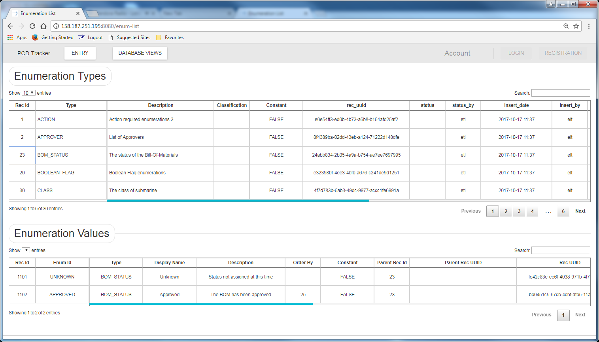

Figure ‑: Enumeration Type and Value Maintenance

### Requirements

### Business Rules

### Views

### Functions

### Data Objects

### Enumerations

### Complexity

|  | Count |
| --- | --- |
| Inputs | 2 |
| Outputs | 1 |
| Inquires | 1 |
| Files/Tables | 1 |
| Ext. Files | 0 |
| Total: | 5 |

### Implementation

## Feedback List

### Human Machine Interfaces

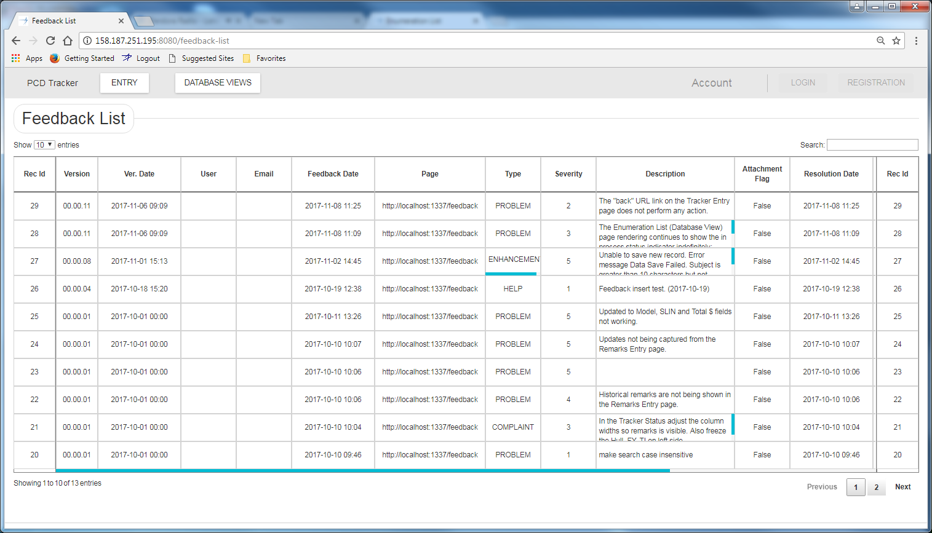

Figure ‑: Feedback List – Database Views

### Requirements

### Business Rules

### Views

### Functions

### Data Objects

### Enumerations

### Complexity

|  | Count |
| --- | --- |
| Inputs | 0 |
| Outputs | 0 |
| Inquires | 0 |
| Files/Tables | 0 |
| Ext. Files | 0 |
| Total: | 0 |

### Implementation

## Remarks List

### Human Machine Interfaces

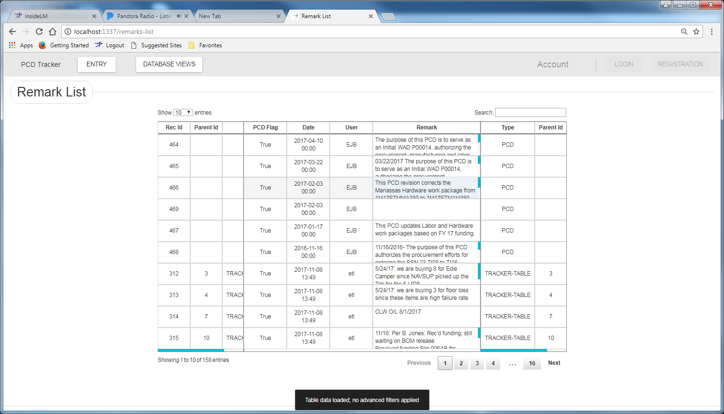

Figure ‑: Remark Maintenance

### Requirements

### Business Rules

### Views

### Functions

### Data Objects

### Enumerations

### Complexity

|  | Count |
| --- | --- |
| Inputs | 2 |
| Outputs | 1 |
| Inquires | 1 |
| Files/Tables | 1 |
| Ext. Files | 0 |
| Total: | 5 |

### Implementation

## Tracker List

### Human Machine Interfaces

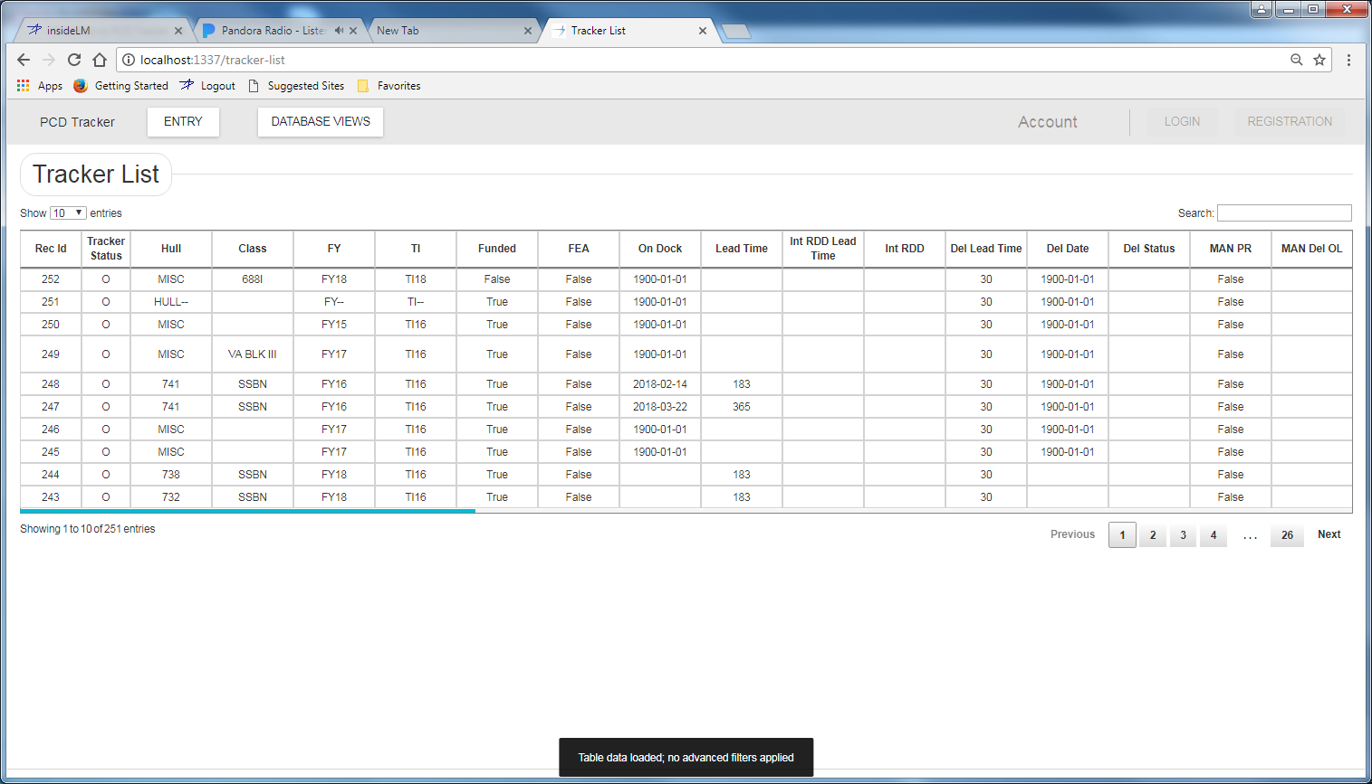

Figure ‑: Tracker Maintenance

### Requirements

### Business Rules

### Views

### Functions

### Data Objects

### Enumerations

### Complexity

|  | Count |
| --- | --- |
| Inputs | 2 |
| Outputs | 1 |
| Inquires | 1 |
| Files/Tables | 1 |
| Ext. Files | 0 |
| Total: | 5 |

### Implementation

## PCD List

### Human Machine Interfaces

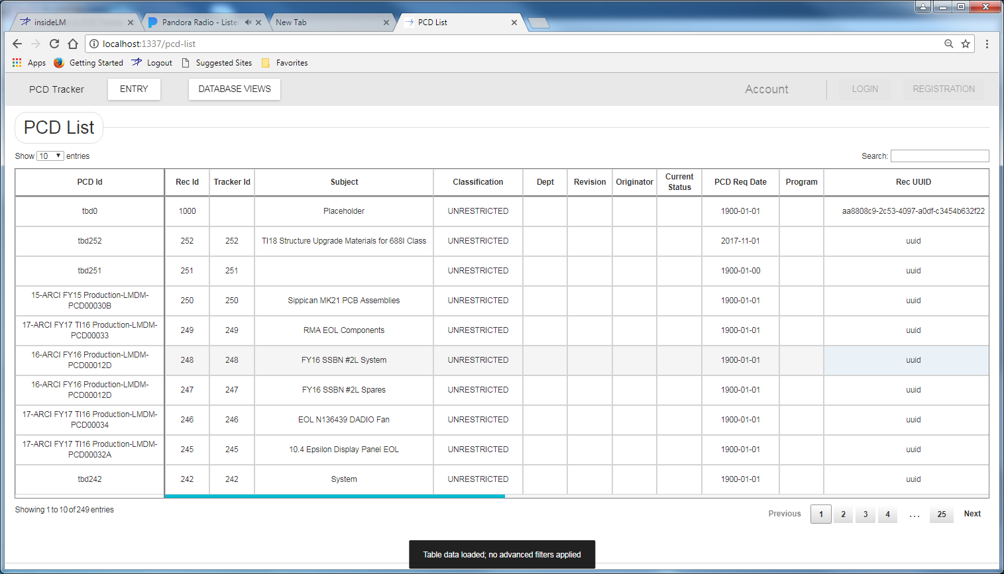

Figure ‑: Tracker Maintenance

### Requirements

### Business Rules

### Views

### Functions

### Data Objects

### Enumerations

### Complexity

|  | Count |
| --- | --- |
| Inputs | 2 |
| Outputs | 1 |
| Inquires | 1 |
| Files/Tables | 1 |
| Ext. Files | 0 |
| Total: | 5 |

### Implementation

# Common Function

## Enumeration Helpers

### Human Machine Interfaces

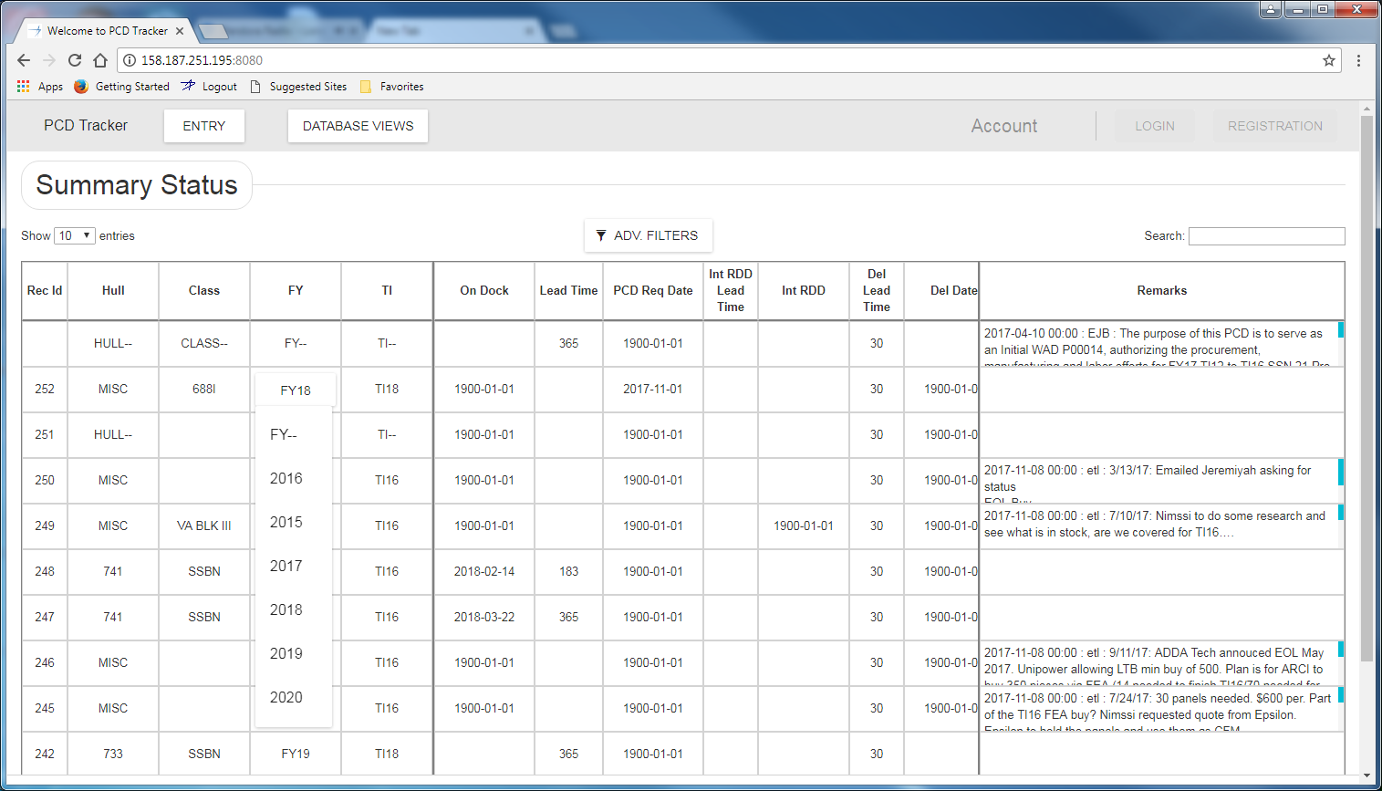

#### Drop Down List Box

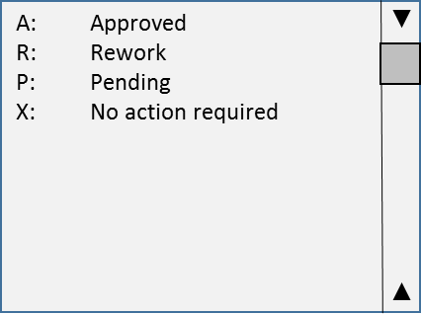

Figure ‑: Drop Down List Box

##### Requirements

##### Business Rules

#### Modal

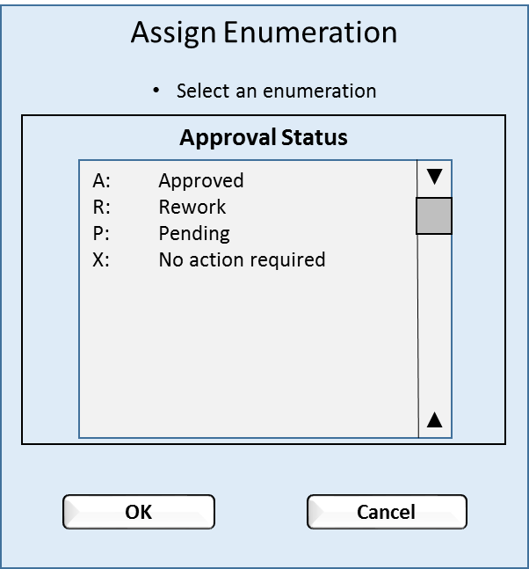

Figure ‑: Enumeration Modal View

##### Requirements

##### Business Rules

### Views

### Functions

### Data Objects

### Enumerations

### Complexity

|  | Count |
| --- | --- |
| Inputs | 1 |
| Outputs | 0 |
| Inquires | 2 |
| Files/Tables | 2 |
| Ext. Files | 0 |
| Total: | 5 |

## Enumeration Types

### Human Machine Interfaces

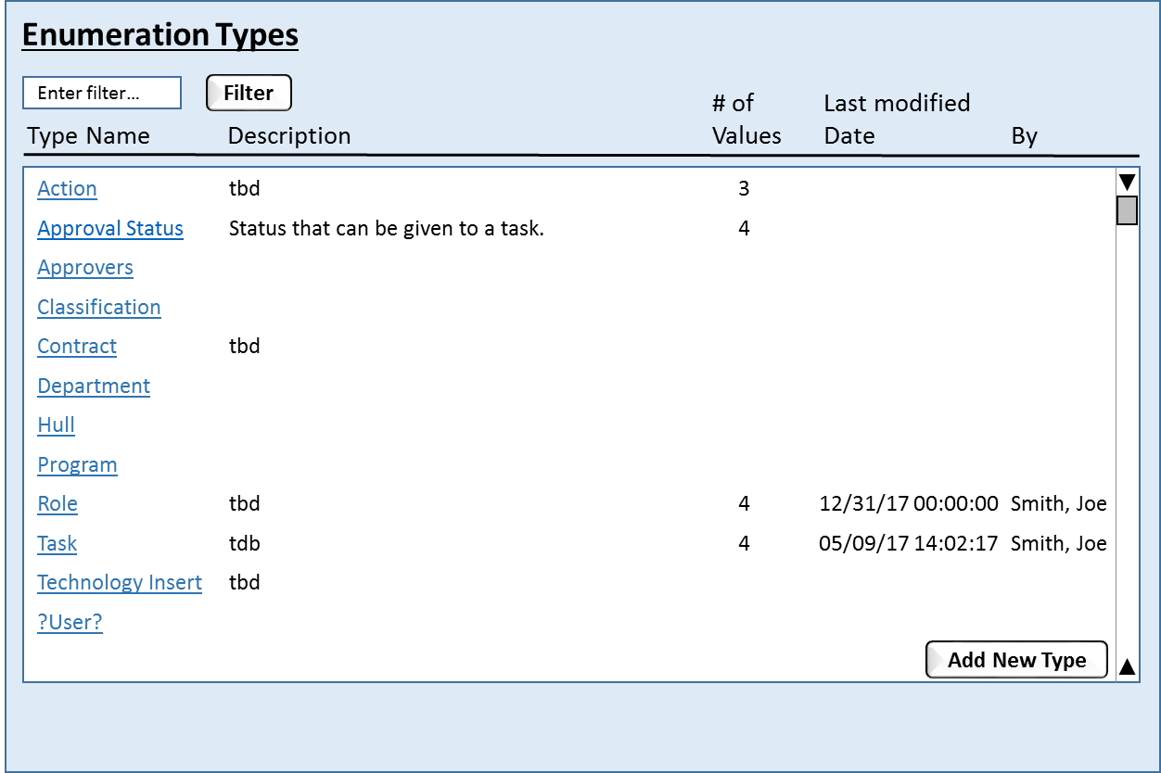

Figure ‑: Enumeration Types

### Requirements

### Business Rules

### Views

### Functions

### Data Objects

### Enumerations

### Complexity

|  | Count |
| --- | --- |
| Inputs | 2 |
| Outputs | 1 |
| Inquires | 1 |
| Files/Tables | 1 |
| Ext. Files | 0 |
| Total: | 5 |

### Implementation



Figure ‑: Enumeration Type and Value Maintenance

## Enumeration Values

### Human Machine Interfaces

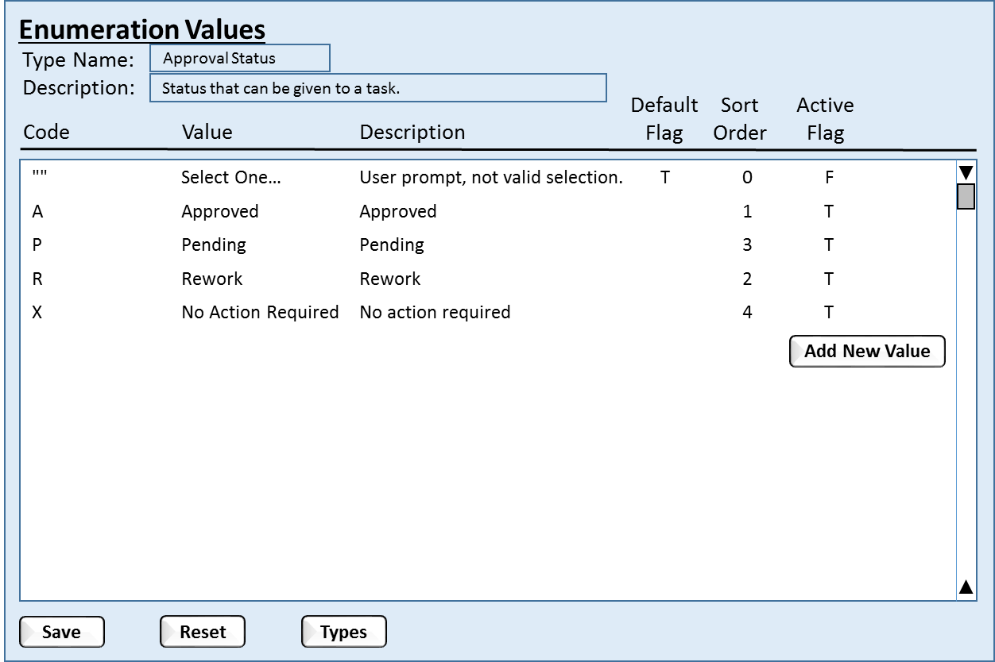

Figure ‑: Enumeration Values

### Requirements

### Business Rules

### Views

### Functions

### Data Objects

### Enumerations

### Complexity

|  | Count |
| --- | --- |
| Inputs | 2 |
| Outputs | 1 |
| Inquires | 2 |
| Files/Tables | 2 |
| Ext. Files | 0 |
| Total: | 7 |

## Enumeration Value Associations

### Human Machine Interfaces

### Requirements

### Business Rules

### Views

### Functions

### Data Objects

### Enumerations

### Complexity

|  | Count |
| --- | --- |
| Inputs | 0 |
| Outputs | 0 |
| Inquires | 0 |
| Files/Tables | 0 |
| Ext. Files | 0 |
| Total: | 0 |

## Printable Version

Converts the ?HTML? into a printable page format. The function is called from the “View PCD” HMI.

<https://www.smashingmagazine.com/2015/01/designing-for-print-with-css/>

### Human Machine Interfaces

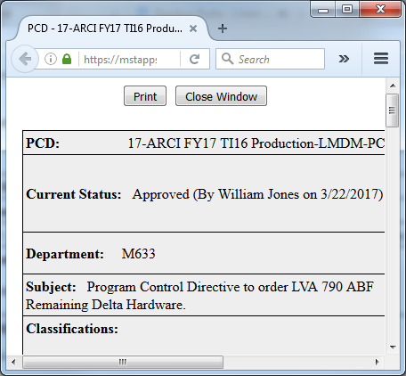

Figure ‑: Printable View

### Requirements

1. The system will determine the classification banner to be printed on the top and bottom of every page based upon the value PCD classification.
2. The system will include the document name on every page.
3. The system will include the web address of the document on every page.
4. The system will include the page number and total number of pages on every page.
5. The system will include the date printed on every page.
6. The system will allow the user to set the printer properties (2-sided, color, etc.)
7. The system will be capable saving the document as a printable file.
8. The system will be capable of producing a PDF document.
9. The system will allow the user to close the page without printing.

### Business Rules

### Views

### Functions

### Data Objects

### Enumerations

### Complexity

|  | Count |
| --- | --- |
| Inputs | 3 |
| Outputs | 0 |
| Inquires | 11 |
| Files/Tables | 6 |
| Ext. Files | 0 |
| Total: | 20 |

## Classification

This allows the user to set the classification level of the PCD. The classification level will be used to the set classification banner on printed and electronic copies of the PCD.

### Human Machine Interfaces

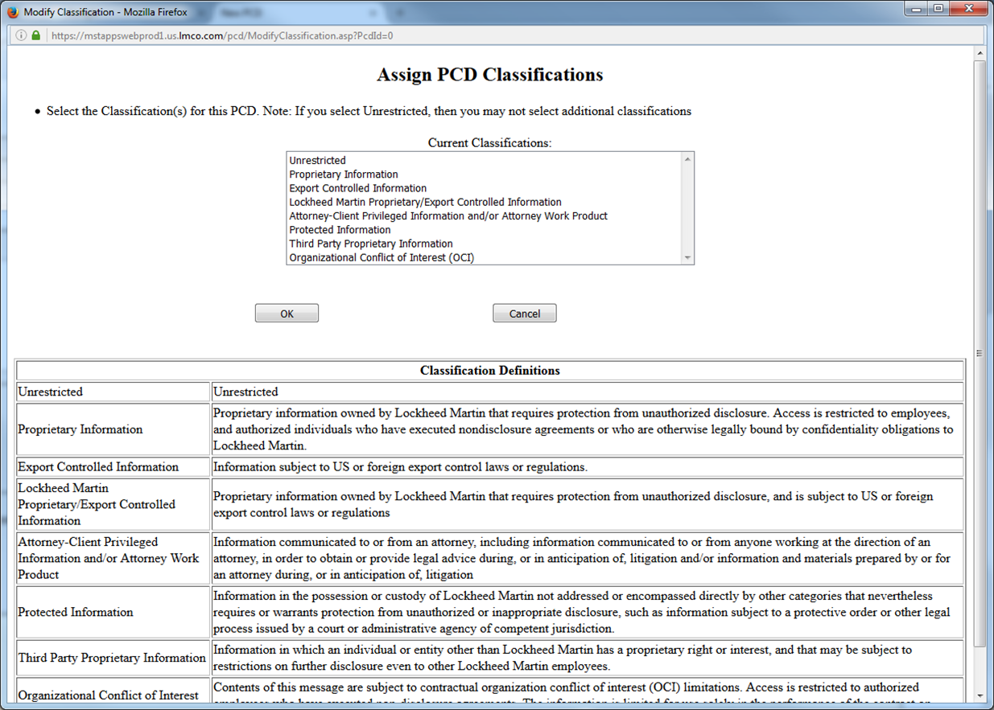

Figure ‑: PCD Classifications

### Requirements

1. The system will track changes to the PCD classification and trigger the creation of a required audit records.

### Business Rules

### Views

### Functions

### Data Objects

### Enumerations

### Complexity

|  | Count |
| --- | --- |
| Inputs | 0 |
| Outputs | 0 |
| Inquires | 0 |
| Files/Tables | 0 |
| Ext. Files | 0 |
| Total: | 0 |

## Contracts / Purchase Order(s)

This is part of the original PCD application. The list is maintained out the ARCI program. This will be move to a ARCI authorized user maintained user enumeration.

### Human Machine Interfaces

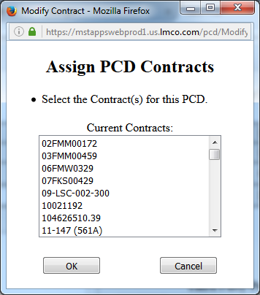

Figure ‑: PCD References

### Requirements

1. The system will convert the contract id to upper case.
2. The system will not allow duplicate contract ids.
3. The system will not allow the user to delete a contract id.
4. The system will allow the user to hidden a contract id so that the contract can be used historical data records.

### Business Rules

### Views

### Functions

### Data Objects

### Enumerations

### Complexity

|  | Count |
| --- | --- |
| Inputs | 0 |
| Outputs | 0 |
| Inquires | 0 |
| Files/Tables | 0 |
| Ext. Files | 0 |
| Total: | 0 |

## Assign Approver(s)

A user maintained list of users with approval authorization.

### Human Machine Interfaces

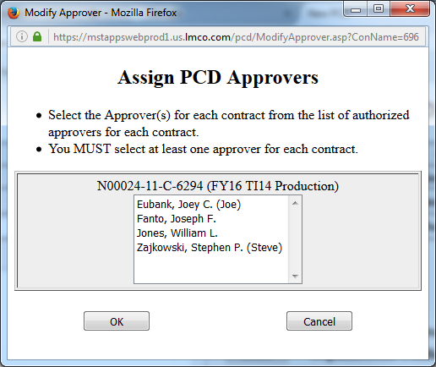

Figure ‑: Assign Approvers

### Requirements

1. The system will validate the user has a valid LM email address.

### Business Rules

### Views

### Functions

### Data Objects

### Enumerations

### Complexity

|  | Count |
| --- | --- |
| Inputs | 0 |
| Outputs | 0 |
| Inquires | 0 |
| Files/Tables | 0 |
| Ext. Files | 0 |
| Total: | 0 |

## Directory Helper

### Human Machine Interfaces

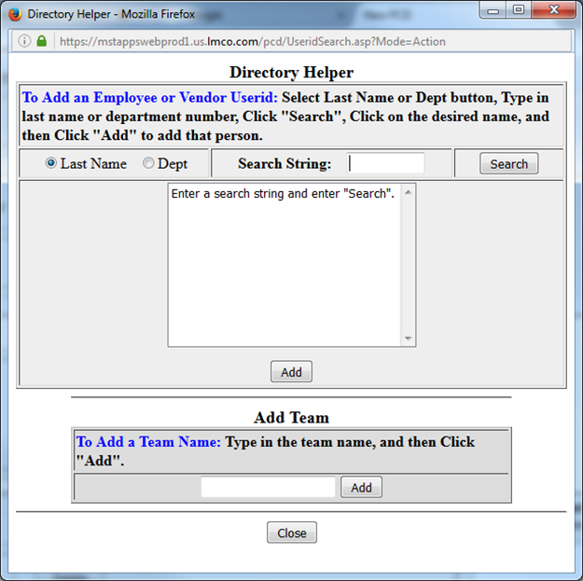

Figure ‑: Directory Helper

### Requirements

1. The system will allow the authorized user to create a user group.
2. The system will allow the authorized user to maintain the user group.
3. The system will allow the user to search for users in the ?LM active directory?.

### Business Rules

### Views

### Functions

### Data Objects

### Enumerations

### Complexity

|  | Count |
| --- | --- |
| Inputs | 0 |
| Outputs | 0 |
| Inquires | 0 |
| Files/Tables | 0 |
| Ext. Files | 0 |
| Total: | 0 |

## Assign Programs

### Human Machine Interfaces

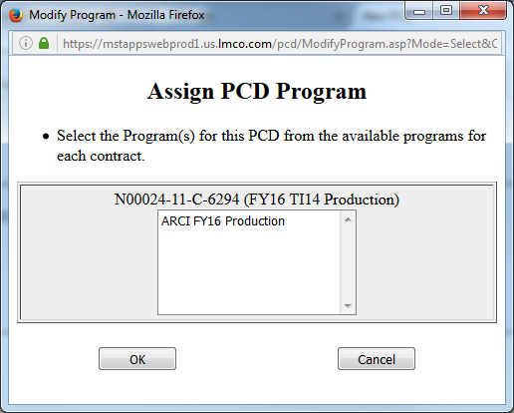

Figure ‑: Assign Programs

### Requirements

### Business Rules

### Views

### Functions

### Data Objects

### Enumerations

### Complexity

|  | Count |
| --- | --- |
| Inputs | 0 |
| Outputs | 0 |
| Inquires | 0 |
| Files/Tables | 0 |
| Ext. Files | 0 |
| Total: | 0 |

## Attachments

Provides the user with a method to add attachments to tasks and PCDs.

### Human Machine Interfaces

#### Add Attachment

The function allows the user to add a file as an attachment.

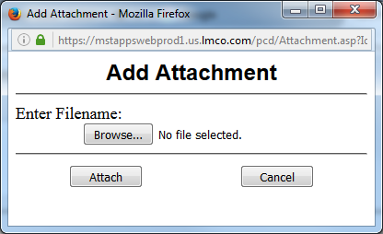

Figure ‑: Add Attachment

##### Requirements

1. The system will validate the selected file exists in the file system.
2. The system will **COPY** the file to a storage location under the PCD application control.

##### Business Rules

1. What is supposed to happen if the user makes changes to a file that has already been attached?

#### File Browser

Provides the user with the ability to search for the file system for the file they wish to attachment.

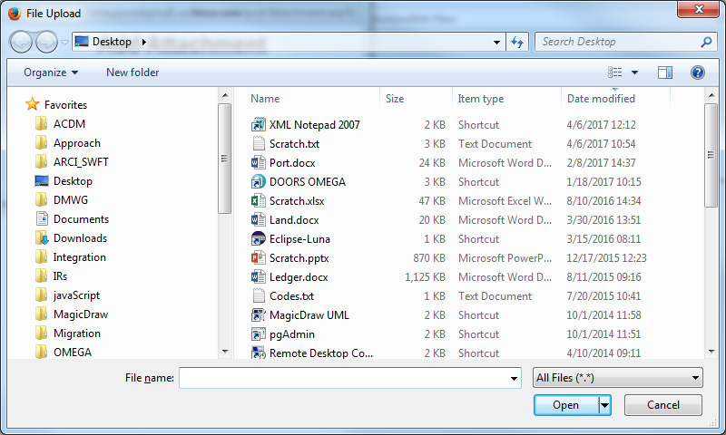

Figure ‑: File Selection Browser

##### Requirements

##### Business Rules

### Views

### Functions

### Data Objects

### Enumerations

### Complexity

|  | Count |
| --- | --- |
| Inputs | 0 |
| Outputs | 0 |
| Inquires | 0 |
| Files/Tables | 0 |
| Ext. Files | 0 |
| Total: | 0 |

## View Attachments

Provides the user with the ability to view attachments that have been added to their assigned tasks.

### Human Machine Interfaces

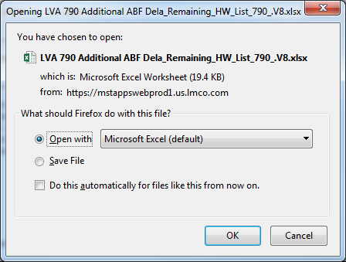

Figure ‑: View Attachment

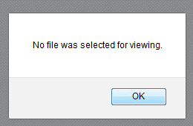

Figure ‑: No File Selected Warning for Viewing

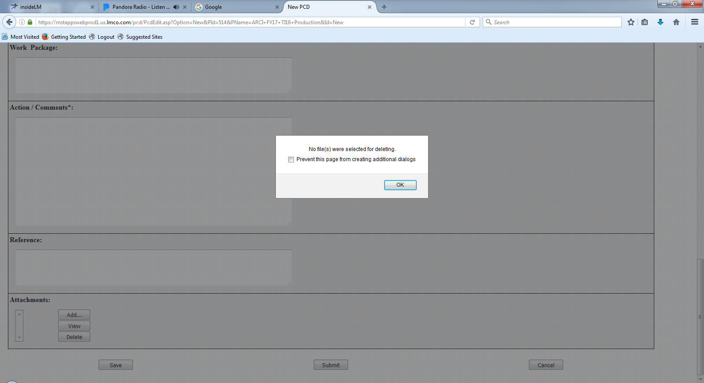

Figure ‑: No Files Selected for Deleting

### Requirements

### Business Rules

### Views

### Functions

### Data Objects

### Enumerations

### Complexity

|  | Count |
| --- | --- |
| Inputs | 0 |
| Outputs | 0 |
| Inquires | 0 |
| Files/Tables | 0 |
| Ext. Files | 0 |
| Total: | 0 |

## PCD Notification

### Human Machine Interfaces

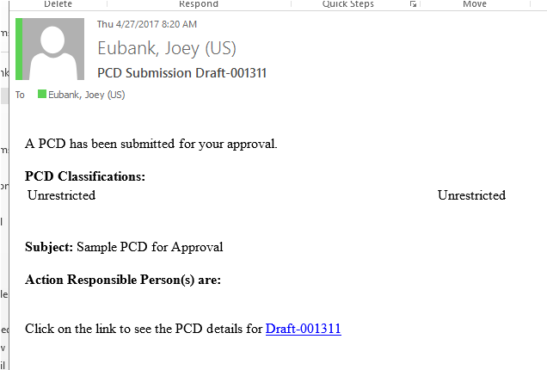

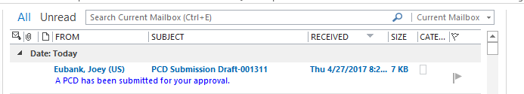

### Requirements

### Business Rules

### Views

### Functions

### Data Objects

### Enumerations

### Complexity

|  | Count |
| --- | --- |
| Inputs | 0 |
| Outputs | 0 |
| Inquires | 0 |
| Files/Tables | 0 |
| Ext. Files | 0 |
| Total: | 0 |

## About

### Human Machine Interfaces

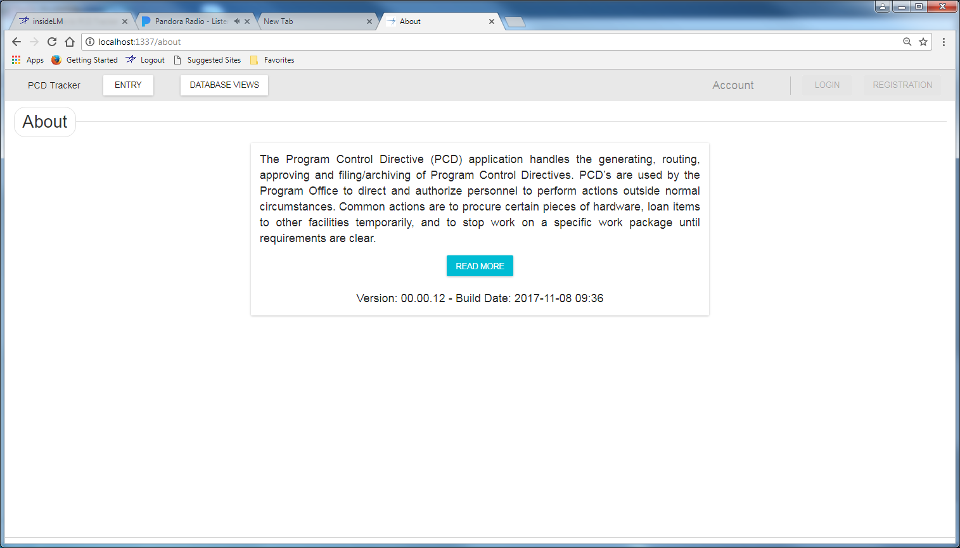

Figure ‑: About Page

### Requirements

### Business Rules

### Views

### Functions

### Data Objects

### Enumerations

### Complexity

|  | Count |
| --- | --- |
| Inputs | 0 |
| Outputs | 0 |
| Inquires | 0 |
| Files/Tables | 0 |
| Ext. Files | 0 |
| Total: | 0 |

## PCD Users Guide

### Human Machine Interfaces

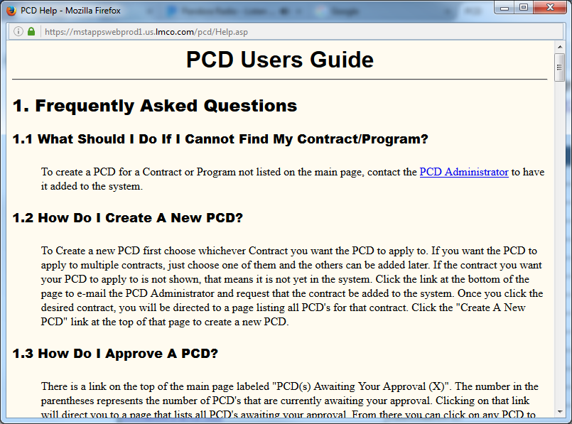

### Requirements

### Business Rules

### Views

### Functions

### Data Objects

### Enumerations

### Complexity

|  | Count |
| --- | --- |
| Inputs | 0 |
| Outputs | 0 |
| Inquires | 0 |
| Files/Tables | 0 |
| Ext. Files | 0 |
| Total: | 0 |

# Application Functions

The application is divided into the following functional parts: Contracts/Programs, Search, and Administration. Each piece is accessible from the home page. The home page initially displays a list of the contracts with a hyperlink to show all PCD's for each contract. The Programs tab may be chosen to change the view to a list of all programs with hyperlinks to show all PCD's for any program. Links are available for the Search and Administration options, although the Administration button is only available to users with Administration authority.

In addition to the main functions of the application, options are available to display help and to get statistics regarding all PCD's or just the PCD's associated with a specified contract or program.

## Contracts/Program List

Allows users to work with PCD's associated with the selected contract or program. This option is selected by clicking on the hyperlink for the desired contract or program on the home page. A list of PCD's associated with that contract or program is displayed. Initially only approved PCD's will be shown. PCD's of other states can be viewed by selecting the checkboxes for the desired states in the Show box at the top of the screen and clicking the Refresh List button. Selecting the hyperlink for any PCD allows the user to work with the individual PCD. PCD's that have an approved revision will appear with a gray background.

### Human Machine Interfaces

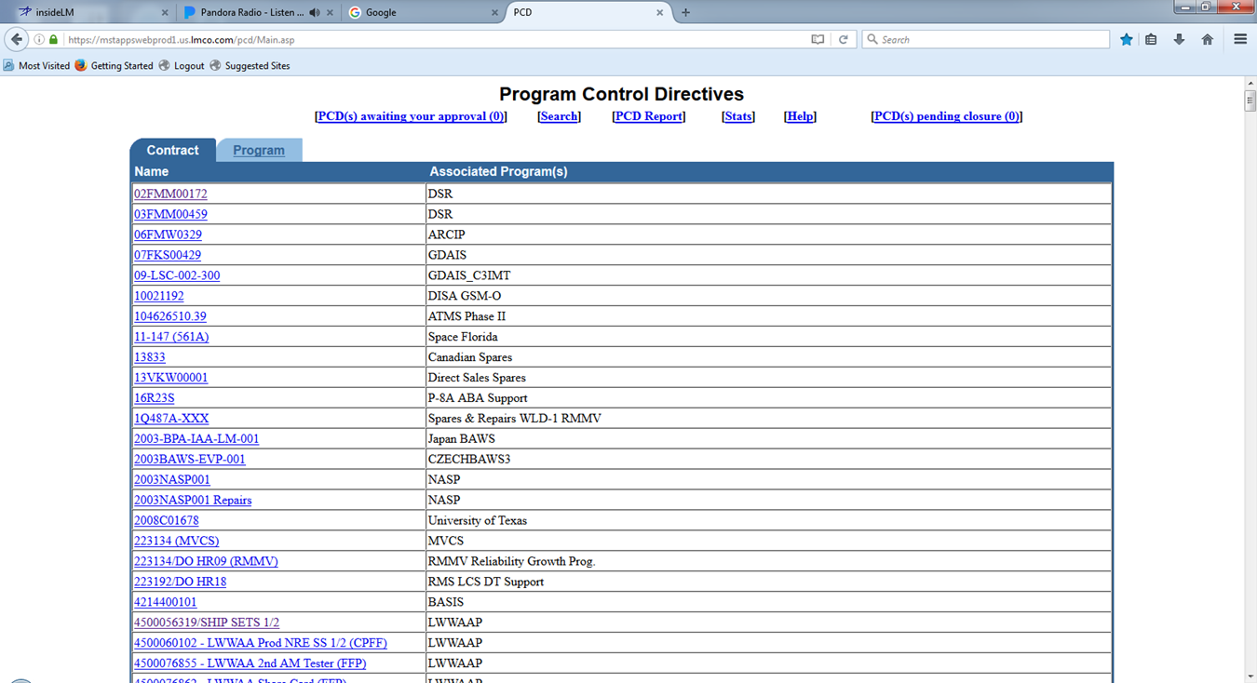

### Requirements

### Business Rules

### Views

### Functions

### Data Objects

### Enumerations

### Complexity

|  | Count |
| --- | --- |
| Inputs | 0 |
| Outputs | 0 |
| Inquires | 0 |
| Files/Tables | 0 |
| Ext. Files | 0 |
| Total: | 0 |

## Administration

The Administration option allows maintenance of the programs and contracts. It also allows addition/removal of system administration authorization. System administrators have access to the Administration option on the home page and are also allowed to edit any PCD in any state.

### Human Machine Interfaces

### Requirements

### Business Rules

### Views

### Functions

### Data Objects

### Enumerations

### Complexity

|  |  |
| --- | --- |
|  | Count |
| Inputs | 0 |
| Outputs | 0 |
| Inquires | 0 |
| Files/Tables | 0 |
| Ext. Files | 0 |
| Total: | 0 |

## PCD Summary

### Human Machine Interfaces

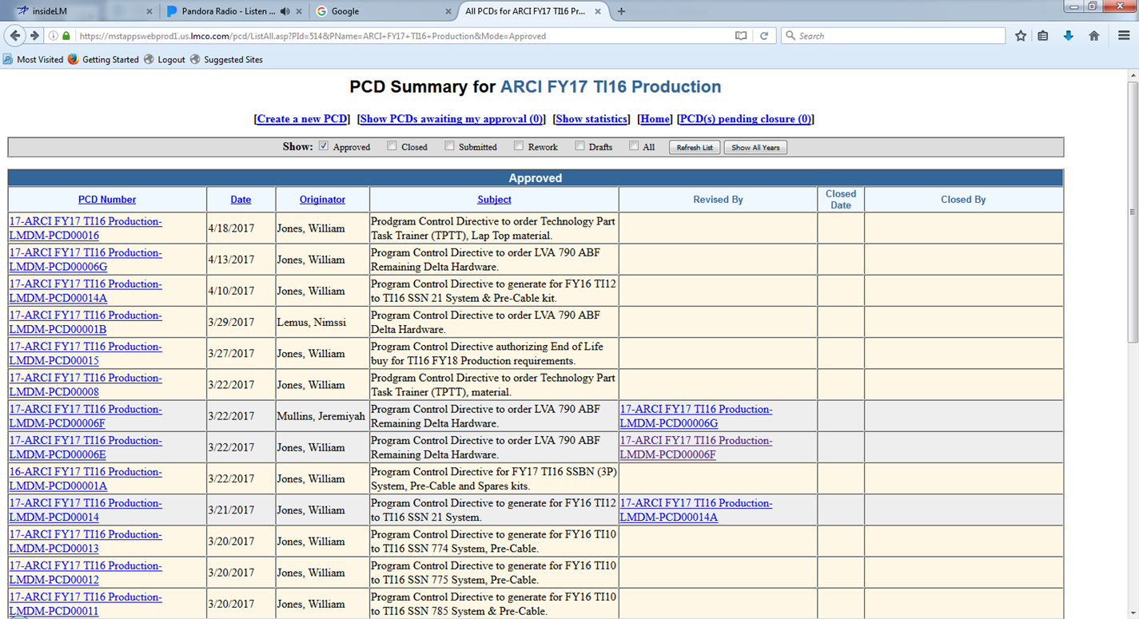

### Requirements

### Business Rules

### Views

### Functions

### Data Objects

### Enumerations

### Complexity

|  | Count |
| --- | --- |
| Inputs | 0 |
| Outputs | 0 |
| Inquires | 0 |
| Files/Tables | 0 |
| Ext. Files | 0 |
| Total: | 0 |

## PCD Report

### Human Machine Interfaces

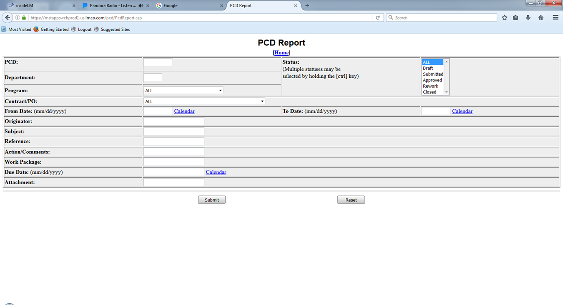

### Requirements

### Business Rules

### Views

### Functions

### Data Objects

### Enumerations

### Complexity

|  | Count |
| --- | --- |
| Inputs | 0 |
| Outputs | 0 |
| Inquires | 0 |
| Files/Tables | 0 |
| Ext. Files | 0 |
| Total: | 0 |

## PCD Statistics

### Human Machine Interfaces

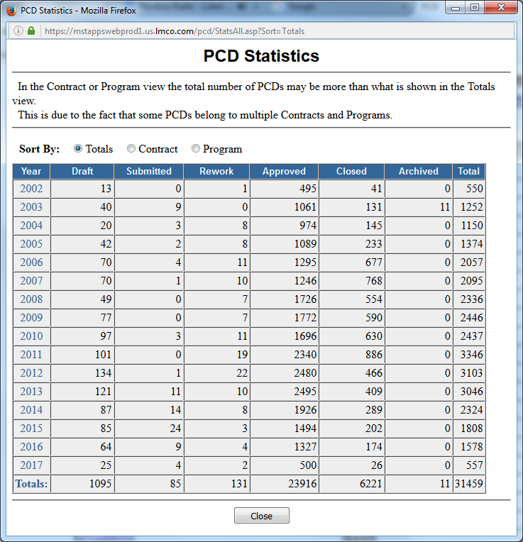

Figure ‑: PCD Statistics (Totals)

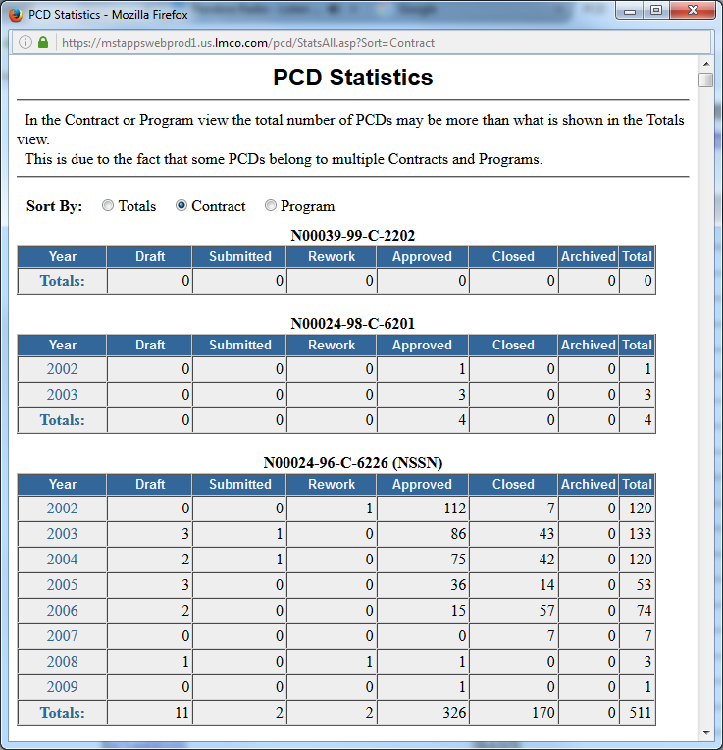

Figure ‑: PCD Statistics (Contract)

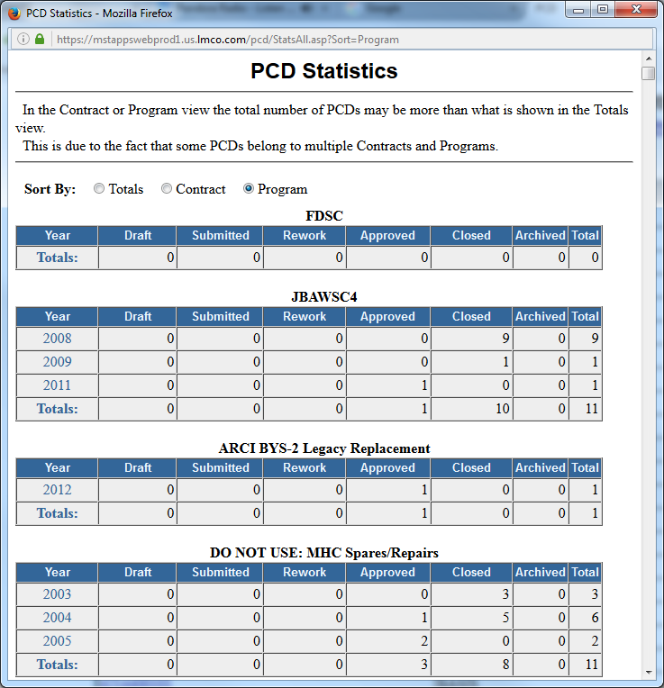

Figure ‑: PCD Statistics (Program)

### Requirements

### Business Rules

### Views

### Functions

### Data Objects

### Enumerations

### Complexity

|  | Count |
| --- | --- |
| Inputs | 0 |
| Outputs | 0 |
| Inquires | 0 |
| Files/Tables | 0 |
| Ext. Files | 0 |
| Total: | 0 |

## Contract Entry

### Human Machine Interfaces

### Requirements

### Business Rules

### Views

### Functions

### Data Objects

### Enumerations

### Complexity

|  | Count |
| --- | --- |
| Inputs | 0 |
| Outputs | 0 |
| Inquires | 0 |
| Files/Tables | 0 |
| Ext. Files | 0 |
| Total: | 0 |

## Program Entry

### Human Machine Interfaces

### Requirements

### Business Rules

### Views

### Functions

### Data Objects

### Enumerations

### Complexity

|  | Count |
| --- | --- |
| Inputs | 0 |
| Outputs | 0 |
| Inquires | 0 |
| Files/Tables | 0 |
| Ext. Files | 0 |
| Total: | 0 |

## User Entry

### Human Machine Interfaces

### Requirements

### Business Rules

### Views

### Functions

### Data Objects

### Enumerations

### Complexity

|  | Count |
| --- | --- |
| Inputs | 0 |
| Outputs | 0 |
| Inquires | 0 |
| Files/Tables | 0 |
| Ext. Files | 0 |
| Total: | 0 |

### Implementation

# Use Cases

This section introduces the relevant decomposed use cases with a use case diagram that depicts the use case names and relationships with stakeholders. Stakeholders can be either users or other system elements.

### [Use Case Name]

This section provides a brief description of the use case including any assumptions and pre/post conditions.

#### [Sequence | Activity] Diagram Name (optional)

This section will contain the sequence or activity diagram depicting the use case flows.

#### Basic Flow

This section will list the steps of the basic flow of events for the use case.

#### Alternate Flows

This section will list the steps for the alternate flow of events.

#### Exceptional Flows

This section will list the steps for the exceptional flow of events.

# Data Model

This section provides a data model for data structures used in the interfaces and data persisted in the data storage subsystem.

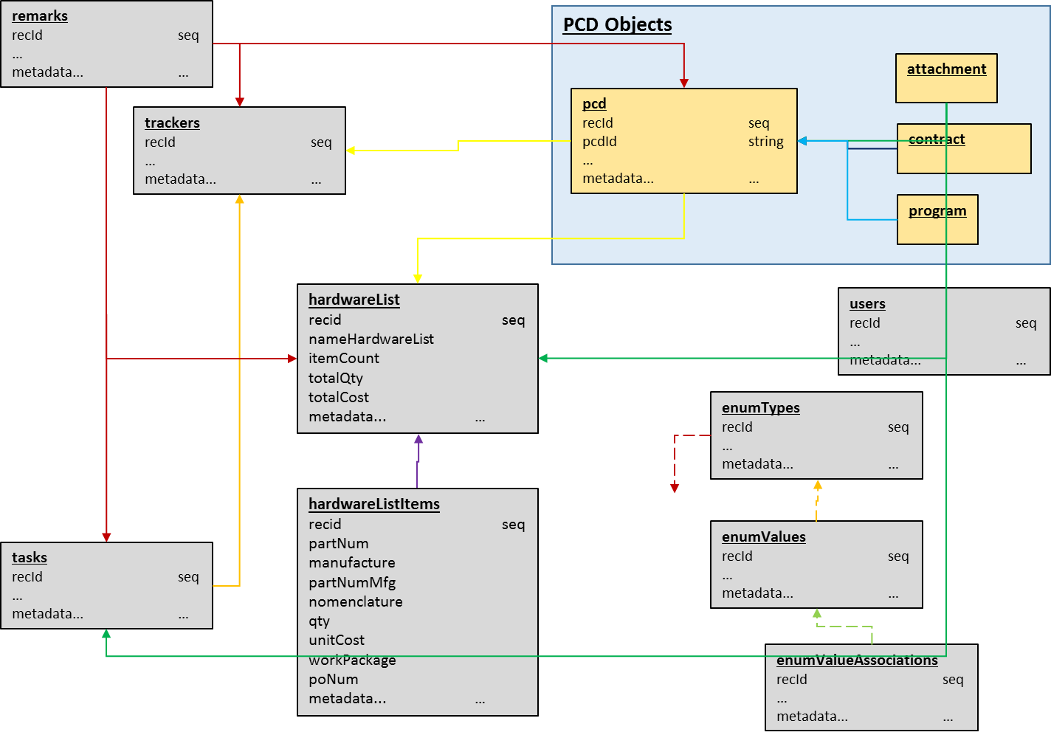

Figure ‑: Data Model

## Tables

### Trackers

Contains all the data need to track the development of the PCD. As of 5/25 there were 180+ entries on the spreadsheet.

Table ‑: Trackers

| Column Name | Data Type | Null | Description |
| --- | --- | --- | --- |
| Rec Id | Sequence | Not | The unique durable single field key assigned to the record. |
| Rec UUID | UUID | Not | Stores the Universally Unique Identifier (UUID) as defined by RFC 4122, ISO/IEC 9834-8:2005. |
| Fiscal Year | String | Not | The fiscal year the tracker is reporting on.  FY--, ‘blanks’ |
| Hull Number | String | Not | The hull number the tracker is reporting on.  Both numbers and strings with the longest string 9 characters.  HULL-- |
| Class | String | Not | The class of the submarine being reported on.  CLASS-- |
| Technical Insert | String | Not | The technical insert the tracker is reporting on.  TI-- |
| Funded Flag | Boolean |  | Flag indicating whether the program is funded.  Yes No ‘blanks’ |
| FEA Flag | String |  | Flag indicating whether the work is being done under a Financial Exposure Authorization (FEA). |
| On Dock/Need Date | Date |  | The date the item(s) is to be delivered to the customer.  Both dates and strings (?, Delivered, TBD, ‘blanks’) |
| PCD Lead Time | Integer |  | The number of days before the ‘On Dock/Need Date’ the PCD should be completed. |
| Internal RDD Lead Time | Integer |  | The number of days before the ‘On Dock/Need Date’ the item should be completed by the production organization. |
| Internal RDD | Date |  | The date the item(s) should be complete by the production organization. |
| Delivery Lead Time | Integer |  | The number of days before the ‘On Dock/Need Date’ the item(s) should be delivered to the customer. |
| Delivery Required | Date |  | The date the item(s) is to be delivered to the customer. |
| Delivery Status | String |  | The delivery status of the items to the client. (‘’, Delivered, Lost, Shipped) |
| MAN PR | Boolean |  | Manassas purchase requisition flag |
| MAN DEL O/L | Date |  | Manassas delivery date outlook.  Dates and strings (Delivered, Partial Delivered, ‘blanks’) |
| CLW PR | Boolean |  | Clearwater purchase requisition flag |
| CLW DEL O/L | Date |  | Clearwater delivery date outlook.  Dates and strings (Delivered, Partial Delivered, ‘blanks’) |
| Part Number | String |  | Part Number or BOM.  Strings and ‘blanks’ with max length of 41. |
| Parts List Status | String |  | The status of the parts list preparation task.  (Released (with date sometimes), No, N/A, ‘blanks’) |
| Drawing Status | String |  | The status of the engineering drawings preparation task.  (Released (with date sometimes), WIP (with date sometimes), No, N/A, ‘blanks’) |
| MOD | String |  |  |
| SLIN | String |  | Sub-line item number |
| Est Dollars | Integer |  | The estimated budget dollars of the PCD. |
| BOM Status | String |  | The status of the bill of materials preparation task. |
| Date Next Review | Date |  | The date the task should next be reviewed. |
| BOILERPLATE |  |  | See ‘Table Boilerplate Suffix’. |

Referenced by:

2.1 - Status Summary

2.2 - PCD Status Search / Report Parameters

2.3 - PCD Tracker Entry

### PCD (Program Control Directives)

Contains the high-level information regarding the PCD.

Table ‑: Program Control Directives (PCD)

| Column Name | Data Type | Null | Description |
| --- | --- | --- | --- |
| Rec Id | Sequence | Not | The unique durable single field key assigned to the record. |
| Rec UUID | UUID | Not | Stores the Universally Unique Identifier (UUID) as defined by RFC 4122, ISO/IEC 9834-8:2005. |
| Tracker ID | Integer (FK) | Not | The integer identifier of the parent record. |
| Tracker UUID | UUID (FK) | Not | The UUID identifier of the parent record. |
| PCD Id | String | Not | A unique identifier for each PCD. It is automatically generated. (ex: DRAFT-ARCI-FY01-TI16-000010)   * The first segment will be a string indicating if the PCD is a ‘DRAFT’ or an approved ‘PCD’. * The second segment will be the program code. ‘ARCI’ * The third segment will be the fiscal year, “FY##’. * The fourth segment will be the technical insertion id, ‘TI16’. * The fifth segment will be a 6-digit sequence number, ‘000010’.   Strings and ‘blanks’ |
| Subject | String | Not | The subject of this PCD; entered by the originator.  Strings and ‘blanks’ with max length of 72 characters |
| Classification Code | String | Not |  |
| Department | String | Not | Text box prefilled with department of the originator, but can be changed to any department. |
| Revision | String |  | This is an uneditable field that shows whether this PCD has had a revision approved. If so, it will show the number of that PCD. If not, it will simply say "Current". |
| Programs | Table |  | Author may select which program(s) this PCD applies to from a list of all programs that the chosen contract(s) apply to |
| Originator | String |  | Uneditable field that shows the name of the PCD's originator. |
| Approver | Table |  | Selected by author from a list of approvers for each contract that a PCD is associated with. One or more approvers must be selected from each Contract that the PCD pertains to. If the same person is an approver for multiple contracts, they may approve for both. |
| Current Status | String |  | Uneditable field filled with the current state of the PCD. In the case of rework, approved, or closed the name of the approver(s) who put it in that state and the date they did it will also be displayed |
| Action Responsible Persons | Table |  | People that are responsible for the action of the PCD. Lookup select by author or a team name that the author enters |
| PCD Required Date | Date |  | The date the PCD is to be ready by.  Contains both dates and strings (‘blanks’) |
| Contracts | Table |  | Shows all contracts or purchase orders that this PCD applies to. |
| Reference | Table |  | Anything this PCD may be in reference to as entered by the author in a text area. |
| Action |  |  | The main content of the PCD |
| Program Recipients | Table |  | Uneditable list of all program recipients. These are the all people on the program recipient lists of all programs associated with this PCD. They will receive a notification e-mail when the PCD is approved. |
| Additional Recipients | Table |  | Any additional people that will get notified when the PCD is approved. The author chooses them through Lookup |
| Work Package |  |  |  |
| Attachments | Table |  | Any files can be stored with the PCD by the author |
| Rework Remarks | Table |  | An approver can fill this field out when designating a PCD for rework. It should contain information regarding what changes are necessary |
| Program to Use in PCD Number | String |  | The author must select the program to have the system use when it assigns a PCD number to the PCD. To set it the author must select a program from the programs box and click the set code button. |
| BOILERPLATE |  |  | See ‘Table Boilerplate Suffix’. |

Referenced by:

2.1 - Status Summary

2.2 - PCD Status Search / Report Parameters

### PCD Sequence

A table to hold the integer value that is incremented each time a new PCD identifier is created.

Table ‑: Hardware Lists

| Column Name | Data Type | Null | Description |
| --- | --- | --- | --- |
| pcd_id_seq | Integer | Not | An integer value that is incremented each time a new PCD identifier is created. |

Referenced by:

8.4.1: f_create_pcd_id

### Hardware (Material) Lists

Is the parent record for the hardware (material) list which contains the high-level information for the a given material list.

Table ‑: Hardware Lists

| Column Name | Data Type | Null | Description |
| --- | --- | --- | --- |
| Rec Id | Sequence | Not | Individual unique identification id for the record. |
| Rec UUID | UUID | Not | Stores the Universally Unique Identifier (UUID) as defined by RFC 4122, ISO/IEC 9834-8:2005. |
| Tracker Id | Integer (FK) |  | The integer identifier of the parent record. |
| Tracker UUID | UUID (FK) |  | The UUID identifier of the parent record. |
| Description Hardware List | Text | Not |  |
| Status Hardware List | Enumeration |  | The development status of the hardware list |
| Department | Enumeration |  |  |
| Item Lines | Integer |  | Number of line items on the hardware list |
| Quantity Total | Integer |  | Total number of items being requested |
| Cost Total | Integer |  | Total cost of items being requested |
|  |  |  |  |
| BOILERPLATE |  |  | See ‘Table Boilerplate Suffix’. |

Referenced by:

Add reference here

### Hardware (Material) List Items

Contains the line item information for the hardware (material) list and is the child of the hardware list table.

Table ‑: Hardware List Items

| Column Name | Data Type | Null | Description |
| --- | --- | --- | --- |
| Rec Id | Sequence | Not | Individual unique identification id for the record. |
| Rec UUID | UUID | Not | Stores the Universally Unique Identifier (UUID) as defined by RFC 4122, ISO/IEC 9834-8:2005. |
| Hardware List Id | Integer (FK) |  | The integer identifier of the parent record. |
| Hardware List UUID | UUID (FK) |  | The UUID identifier of the parent record. |
| Parts Grouping | Enumeration |  | The name of a logical collection of items that shared a common trait |
| Part Number |  |  | Part number for the item being requested |
| Part Number Manufacture |  |  | Manufacture’s part number for the item being requested |
| Nomenclature |  |  | Description of the item being requested |
| Quantity Needed |  |  | The quantity of the item being requested |
| Cost Unit |  |  | The unit cost of 1 of the item |
| Work Package |  |  | The work package for the item being requested |
| Date Required |  |  | The date the item is required by |
|  |  |  |  |
| BOILERPLATE |  |  | See ‘Table Boilerplate Suffix’. |

Referenced by:

Add reference here

### Remarks

Contains a remark information about a given PCD, tasks, or item. There can be multiple remarks linked to the parent record.

Table ‑: Remarks

| Column Name | Data Type | Null | Description |
| --- | --- | --- | --- |
| Rec Id | Sequence | Not | Individual unique identification id for the record. |
| Rec UUID | UUID | Not | Stores the Universally Unique Identifier (UUID) as defined by RFC 4122, ISO/IEC 9834-8:2005. |
| Parent Rec ID | Integer (FK) | Not | The integer identifier of the parent record. |
| Parent Rec UUID | UUID |  | The UUID identifier of the parent record. |
| Remark Type | Enumeration | Not | (tracker, task, review, rework) |
| PCD Flag | Boolean | Not | Flag that indicates if the remark is to be included in the PCD. |
| Date | date |  | The date the remark was enter into the application. |
| User | text |  | The user id of the individual making the remark. |
| Remark | text |  | The text field containing the actual remark.  The max length on spreadsheet is 620 characters |
|  |  |  |  |
| BOILERPLATE |  |  | See ‘Table Boilerplate Suffix’. |

Referenced by:

Add reference here

### Tasks

Contains the task information for a specific tracker record. There can be multiple task records linked to the parent tracker record.

Table ‑: Tasks

| Column Name | Data Type | Null | Description |
| --- | --- | --- | --- |
| Rec Id | Sequence | Not | Individual unique identification id for the record. |
| Rec UUID | UUID | Not | Stores the Universally Unique Identifier (UUID) as defined by RFC 4122, ISO/IEC 9834-8:2005. |
| Parent Rec ID | Integer (FK) | Not | The integer identifier of the parent record. |
| Parent Rec UUID | UUID (FK) | Not | The UUID identifier of the parent record. |
| Task Type | Enumeration |  | (BOM, DOA, DWG, HL, PCD) |
| Description Task |  |  | Title for work to be completed. |
| Task Responsible Individual |  |  | The user of the id of the individual assigned to complete/manage the task. |
| Status Task |  |  | The overall status of the task. |
| Date Required |  |  | The date the task needs to be completed by. |
|  |  |  |  |
| BOILERPLATE |  |  | See ‘Table Boilerplate Suffix’. |

Referenced by:

Add reference here

### User Tasks

Contains the users associated with a given task.

Table ‑: User Tasks

| Column Name | Data Type | Null | Description |
| --- | --- | --- | --- |
| Rec Id | Sequence | Not | Individual unique identification id for the record. |
| Rec UUID | UUID | Not | Stores the Universally Unique Identifier (UUID) as defined by RFC 4122, ISO/IEC 9834-8:2005. |
| User |  |  | The user id of the individual assigned a role on the task. |
| User Role Type | Enumeration |  | The role the user is responsible for on the task. |
| Status User Role | Enumeration |  | The status of the user’s activity on the task. |
|  |  |  |  |
| BOILERPLATE |  |  | See ‘Table Boilerplate Suffix’. |

Referenced by:

Add reference here

### Contracts

Contains the contracts available for use in the PCD. Enumeration?

Table ‑: Contracts

| Column Name | Data Type | Null | Description |
| --- | --- | --- | --- |
| Rec Id | Sequence | Not | Unique integer for the enumeration type to set it apart from the other enumeration types. |
| Rec UUID | UUID | Not | Unique identifier for the enumeration type to set it apart from the other enumeration types. |
| Contract ID | Text | Not |  |
| Contract Description | Text |  |  |
|  |  |  |  |
|  |  |  |  |
|  |  |  |  |
|  |  |  |  |
| BOILERPLATE |  |  | See ‘Table Boilerplate Suffix’. |

Referenced by:

2.2 - PCD Status Search / Report Parameters

### Search Parameters

Contains the ‘where’ clause from the users last successful search and/or report.

Table ‑: Search Parameters

| Column Name | Data Type | Null | Description |
| --- | --- | --- | --- |
| Rec Id | Sequence | Not | Unique integer for the enumeration type to set it apart from the other enumeration types. |
| Rec UUID | UUID | Not | Unique identifier for the enumeration type to set it apart from the other enumeration types. |
| User ID | Text | Not | The user id of the individual the search parameters are for. |
| Where Clause | Text | Not | A string that contains the actual search parameters. |
|  |  |  |  |
| BOILERPLATE |  |  | See ‘Table Boilerplate Suffix’. |

Referenced by:

Add reference here

### Attachments

The record containing the attachment information. There can be multiple attachment records linked to the parent record.

Table ‑: Attachments

| Column Name | Data Type | Null | Description |
| --- | --- | --- | --- |
| Rec Id | Sequence | Not | Unique integer for the enumeration type to set it apart from the other enumeration types. |
| Rec UUID | UUID | Not | Unique identifier for the enumeration type to set it apart from the other enumeration types. |
| File Type | Enumeration | Not | The identifying name given for the specific kind of type the attachment is. |
| Filename |  | Not | The identifying name given to the attachment. |
| File Extension | Enumeration | Not | The group of letters occurring after a period in a file name, indicating the format of the attachment. |
| Directory Path | Text | Not | The unique location within the file system where the attached is located. |
|  |  |  |  |
| BOILERPLATE |  |  | See ‘Table Boilerplate Suffix’. |

Referenced by:

Add reference here

### Enumeration Types

The overarching data object that represents whole enumerations in the database by their names.

Table ‑: Enumeration Types

| Column Name | Data Type | Null | Description |
| --- | --- | --- | --- |
| Rec Id | Sequence | Not | Unique integer for the enumeration type to set it apart from the other enumeration types. |
| Rec UUID | UUID | Not | Unique identifier for the enumeration type to set it apart from the other enumeration types. |
| Enumeration Type | text |  | Identifying name of the enumeration in the database. |
| Description | text |  | Brief description of the enumeration. |
| Date Created | timestamp with timezone |  | See BOILERPLATE. |
| Date Modified | timestamp with timezone |  | See BOILERPLATE. |
| Last Modified By | text |  | See BOILERPLATE. |
| Classification | text |  | Overall classification of the enumeration and all of its values. |
| Constant | bool |  | Whether or not the enumeration is constant (unchangeable, probably used in the system), or dynamic (changeable, probably just used for visualization purposes). |
|  |  |  |  |
| BOILERPLATE |  |  | See ‘Table Boilerplate Suffix’. |

Referenced by:

Add reference here

### Enumeration Values

Individual enumeration values that belong under a particular enumeration type.

Table ‑: Enumeration Values

| Column Name | Data Type | Null | Description |
| --- | --- | --- | --- |
| Rec Id | Sequence | Not | Unique integer for the enumeration value to set it apart from the other enumeration values. |
| Rec UUID | UUID | Not | Unique identifier for the enumeration value to set it apart from the other enumeration values. |
| Parent Rec ID | Integer (FK) | Not | The integer identifier of the parent record. |
| Parent Rec UUID | UUID |  | The UUID identifier of the parent record. |
| Enumeration Type | uuid | not | Name/identifier of the overarching enumeration type that this value belongs to. |
| Enumeration Value | text | not | The actual specific enumeration value. |
| Order By | int |  | Integer value used to create a custom sort order not possible programmatically. |
| Enumeration Display Name | text |  |  |
| Description | text |  | Brief description of the enumeration value. |
| Constant | bool |  | Whether or not enumeration value is unchangeable or dynamic. |
|  |  |  |  |
| BOILERPLATE |  |  | See ‘Table Boilerplate Suffix’. |

Referenced by:

Add reference here

### Enumeration Value Associations

Values that are in some way associated with a particular enumeration value. For example, an associated value would be a displayable name for a particular enumeration value to use whenever it is rendered in a selectable drop-down list in a GUI.

Table ‑: Enumeration Value Associations

|  |  |  |  |
| --- | --- | --- | --- |
| Column Name | Data Type | Null | Description |
| Rec Id | Sequence | Not | Unique integer for the enumeration value to set it apart from the other enumeration values. |
| Rec UUID | UUID | Not | Unique identifier for the enumeration value to set it apart from the other enumeration values. |
| Enumeration Value UUID | uuid |  | UUID for enumeration value this associated value is connected to. |
| Associated Enumeration Value | text |  | Actual associated enumeration value for particular enumeration value. |
| Data Type | text |  | Datatype that associated value should be rendered as. |
| Value Descriptor | text |  | Unique descriptor of associated value used to identify particular associated value. |
| Constant | bool |  | Whether or not associated value is associated with an enumeration value that is dynamic or not. |
|  |  |  |  |
| BOILERPLATE |  |  | See ‘Table Boilerplate Suffix’. |

Referenced by:

Add reference here

### Boilerplate Suffix

This a set of fields that would part of every table. Because the filed definitions don’t change between tables they are defined once here and referred to as “**BOILERPLATE**” at the end each table.

Table ‑: Boilerplate

| Column Name | Data Type | Null | Description |
| --- | --- | --- | --- |
| status | Char(1) | Not | A 1 character code for the status of the record, (Current, Error, Historical, New, Processing, Waiting).  DEFAULT 'C' |
| status_by | Varchar(50) | Not | The user who last changed the status of the record.  DEFAULT USER |
| status_date | Timestamp | Not | The date when the record status was last changed.  DEFAULT CLOCK_TIMESTAMP() |
| insert_date | Timestamp |  | The date the record was created.  DEFAULT CLOCK_TIMESTAMP() |
| insert_by | Varchar(50) |  | The user/function that created the record.  DEFAULT USER |
| update_date | Timestamp |  | The date the record was last modified. |
| update_by | Varchar(50) |  | The user/function that last updated the record. |
| delete_flag | Boolean |  | A logical flag used to ignore the record as if it was deleted.  DEFAULT 'FALSE |
| delete_date | Timestamp |  | The date the logical delete flag was set. |
| delete_by | Varchar(50) |  | The user/function that set the logical delete flag. |
| hidden_flag | Boolean |  | A flag used to hide/exclude the record from pick lists.  DEFAULT 'FALSE |
| hidden_date | Timestamp |  | The date the hidden flag was set. |
| hidden_by | String |  | The user/function that set the hidden flag. |
|  |  |  |  |

Referenced by:

Add reference here

### Blank Table

The overarching data object that represents whole enumerations in the database by their names.

Table ‑: Blank

| Column Name | Data Type | Null | Description |
| --- | --- | --- | --- |
| Rec Id | Sequence | Not | Unique integer for the enumeration type to set it apart from the other enumeration types. |
| Rec UUID | UUID | Not | Unique identifier for the enumeration type to set it apart from the other enumeration types. |
| Parent Rec Id | Integer | Not | The integer identifier of the parent record. |
| Parent Rec UUID | UUID | Not | The UUID identifier of the parent record. |
|  |  |  |  |
|  |  |  |  |
|  |  |  |  |
|  |  |  |  |
| BOILERPLATE |  |  | See ‘Table Boilerplate Suffix’. |

Referenced by:

Add reference here

## Views

A view is the result set of a stored query on the data, which the database users can query just as they would in a persistent table. This pre-established query command is kept in the database dictionary. Unlike ordinary base tables in a relational database, a view does not form part of the physical schema: as a result set, it is a virtual table computed or collated dynamically from data in the database when access to that view is requested. Changes applied to the data in a relevant underlying table are reflected in the data shown in subsequent invocations of the view.

### vw_end_of_life

### vw_hw_list_all

### vw_hw_list_items_all

### vw_pcd_delivery_wakeup

### vw_pcd_funded_no_pcd

### vw_pcd_fy_not_funded

### vw_pcd_wakeup

### vw_remarks

### vw_task_all

### vw_tracker_active

### vw_tracker_all

### vw_tracker_pcd

### vw_user_feedback_all

### Blank View

The overarching data object that represents whole enumerations in the database by their names.

Table ‑: Blank

| Column Name | Data Type | Null | Description |
| --- | --- | --- | --- |
| Rec Id | Sequence | Not | Unique integer for the enumeration type to set it apart from the other enumeration types. |
| Rec UUID | UUID | Not | Unique identifier for the enumeration type to set it apart from the other enumeration types. |
| Parent Rec Id | Integer | Not | The integer identifier of the parent record. |
| Parent Rec UUID | UUID | Not | The UUID identifier of the parent record. |
|  |  |  |  |
|  |  |  |  |
|  |  |  |  |
|  |  |  |  |
| BOILERPLATE |  |  | See ‘Table Boilerplate Suffix’. |

Referenced by:

Add reference here

## Triggers

A database trigger is procedural code that is automatically executed in response to certain events on a particular table or view in a database. The trigger is mostly used for maintaining the integrity of the information on the database. For example, when a record is added/updated/deleted in a table, audit records should also be created in the audit tables to log historical data changes to the record.

### enum_types_insert_before

### enum_values_insert_before

### pcd_insert_before

### remarks_insert_before

### trackers_insert_before

### 

## Functions

A user-defined function is a SQL routine that accepts parameters, performs an action, such as a complex calculation, and returns the result of that action as a value. The return value can either be a scalar (single) value or a table.

### f_create_pcd_id

Generates a unique PCD identifier conforming to the following pattern:   
<ARCI>-<FY##>-<TI##>-SEQ#-<Draft>

### f_remarks_string

### uuid_v4

### 

## Procedures

### 

## Schema Post Deployment Scripts

### 

# [CSCI Name] CSCI

This begins the definition of “WILLS” for the function. This section should include a CSCI block diagram which includes the CSCs that are to be described below. Requirements may be written in this paragraph if they apply to all CSCs.

## [CSC Name] CSC

This section should start with a brief description of the CSC.

### [Function Name]

This section describes a function of the CSC. Each function allocated to the CSC should reside under its own heading, so there may be multiple sections. Test methods can be embedded within the descriptions. If so, place a note in section 2.4 that states the embedded approach.

#### Test Method

This section provides CQT level test description for the function described above.

#### Algorithms (if applicable)

This section should describe any algorithms needed for the SW team to implement.

#### SW Reuse (if applicable)

This section examines the proposed software reuse that was identified during the replan estimation process. (see Alan’s ppt at: <https://www.silcweb.com/silc/?u=bpw>).

#### Requirements Traceability

This section provides a traceability matrix for the SSS and PBS requirements related to the CSC specification.

## Data Model

This section provides a data model for data structures used in the interfaces and data persisted in the data storage subsystem.

## Interfaces

This section provides interface definitions for GUIs or public interfaces that cross subsystem boundaries.

### Graphical Interfaces (if applicable)

This section provides applicable GUI mockups with description.

### Message Interfaces (if applicable)

This section provides message interface definitions, including message names, parameter list, and return values, if applicable.

#### Provided Interfaces

This section describes the public interfaces provided by the CSCI.

#### Required Interfaces

This section describes the public interfaces required by the CSCI.

# Appendixes

## Acronyms

| Acronym | Description |
| --- | --- |
| ARCI | Acoustic Rapid Commercial-Off-The-Shelf Insertion |
| BOM | Bill of Materials |
| CAM | Control Account Manager |
| CLR | Clearwater |
| ER | Engineering Release |
| EVM | Earned Value Management |
| FEA | Financial Exposure Authorization |
| LMDM | Lockheed Martin Data Management |
| MAN | Manassas |
| MPM |  |
| PC |  |
| PCD | Program Control Directive |
| PM | Project Manager |
| PN | Part Number |
| PO | Purchase Order |
| POP | Period of Performance |
| PPM |  |
| PR | Purchase Requisition |
| RDD | Required Delivery Date |
| SLIN | Sub-Line Item Number |
| TI | Technology Insertion |
| iWAD | “Initial” Work Authorization Directive |

## Enumeration Types

| Enumeration | Value | Code | Description |
| --- | --- | --- | --- |
| Action |  |  |  |
| Approvers |  |  |  |
| Classifications |  |  |  |
| Contracts |  |  |  |
| Departments |  |  |  |
| Fiscal Year |  |  |  |
| Hull |  |  |  |
| Lead Time Delivery |  |  |  |
| Lead Time PCD |  |  |  |
| Programs |  |  |  |
| Role |  |  |  |
| Status Delivery |  |  |  |
| Status Drawings |  |  |  |
| Status Parts List |  |  |  |
| Tasks |  |  |  |
| Technology Insertion |  |  |  |
| Users |  |  |  |

## Enumeration Values

| Enumeration | Value | Code | Description |
| --- | --- | --- | --- |
|  |  |  |  |
| Authorized Users |  |  |  |
| Contract |  |  |  |
|  |  |  |  |
| FEA |  | NA |  |
|  |  | N |  |
|  |  | Y |  |
|  |  |  |  |
| Fiscal Year |  |  |  |
| Hull |  |  |  |
|  |  |  |  |
|  |  |  |  |
| Lead Time Delivery |  |  |  |
| Lead Time PCD |  |  |  |
|  |  |  |  |
| State PCD |  | D | Draft |
|  |  | S | Submitted |
|  |  | R | Rework |
|  |  | A | Approved |
|  |  |  |  |
|  |  |  |  |
| Status Bill of Materials |  | “” | Blank |
|  |  | PR | Pre-Release |
|  |  | R | Release |
|  |  |  |  |
| Status Delivery |  | “” | Blank |
|  |  | D | Delivered |
|  |  | L | Lost |
|  |  | S | Shipped |
|  |  |  |  |
| Status Drawings |  | “” | Blank |
|  |  | PR | Pre-Release |
|  |  | R | Release |
| Status Parts List |  | “” | Blank |
|  |  | PR | Pre-Release |
|  |  | R | Release |
|  |  |  |  |
| Status PCD |  | A | Approved |
|  |  | R | Rework |
|  |  | P | Pending |
|  |  | X | No Action Required |
|  |  |  |  |
|  |  |  |  |
| Task Type |  | “” | Blank |
|  |  | BOM | Bill of Materials |
|  |  | DWG | Drawings |
|  |  | PCD | Program Control Directives |
|  |  | PN | Part Number |
|  |  | PR | Purchase Requisition |
|  |  |  |  |
| Technology Insertion |  |  |  |
|  |  |  |  |
|  |  |  |  |
|  |  |  |  |